Business Cases for Foreign Direct Investment on Vancouver Island
Prepared for the Vancouver Island Economic Alliance and Foreign Trade Zone Vancouver Island by
Bill Collins and John McCannel
February, 2019

Acknowledgements
The team would like to acknowledge the support of VIEA and in particular Mr. George Hanson, President. Through the development of this report we had many engaging and enlightening conversations in communities across Vancouver Island. We would like to thank the many individuals for their valuable time. In particular, thanks to Mr. Frank Bouree and Emily de Rosenroll of the South Island Prosperity Project and Rob Bennett of Viatec. Export Development Canada’s Brian Hughes and Chris Theeparajah as well as Peter Moonen of BC Wood Council and Mike Marshall of Kinsol Timber. Andrew Wynn-Williams of the Canadian Manufacturers and Exporters Association connected us with great companies working on Vancouver Island and Mark Gray-Draper of XPS Solutions and Rob Napoli of Promerita Capital Partners helped us to understand the foreign and domestic investment climate.
Pamela Hart was a tremendous help at the initial stages of the project in pulling together information across the many business sectors on the Island.
Thanks to our hosts around the Island including Pat Deakin, Dave McCormick, Mike Hooper and Rose Klukas as well as Patrick Schmidt and Jim Lee of the HFN Group of Businesses. A special thanks to Rob Walker of Agrimarine who showed us around their operations and provided us with valuable insights. Thanks to Bret Torok-Both and the members of the VIEA Wood Committee and John Paul Fraser, Stephen Cross, Linda Sams and Marilyn Hutchinson who spent the morning with us in Campbell River. Thanks also goes to Wayne Colson of The Colson Group for his perspective on Island business and Trevor Cootes, Director, Huu-ay-aht First Nations Government.
We wish also to acknowledge the discussions with Richard Egil and Ania Wysocka of Alacrity Canada and Rob O’Brien formally of the Ministry of Jobs, Training and Technology of the Government of BC. Thanks also to Ted Olak and Vivian Kan of BDC.
A very special thanks goes to the Foreign Trade Zone and Foreign Direct Investment committees of VIEA who had the insight to see business on Vancouver Island as a natural destination for foreign direct investment.

Table of Contents
Acknowledgements 2
Executive Summary 5
Introduction 10
Background 11
Approach 12
Business Cases 16
Non-Market Forces 17
Business Case Introduction 20
Transportation 20
Regulatory Oversight 21
Sustainable Aquaculture Business Case 23
Product Overview 23
Business Overview 24
Financial Overview 34
Marketable Waste Wood Business Case 37
Product Overview 37
Business Overview 38
Financial Overview 42
Cultural and Eco Tourism Business Case 45
Product Overview 45
Business Overview 47
Financial Overview 55
Clean Technologies Business Case 58
Product Overview 59
Business Overview 60
Financial Overview 65
Summary and Recommendations 68
Appendix A The Team 71
Appendix B Round of Thirty 72
Appendix C Focus Group Template 73

Executive Summary
The Vancouver Island Economic Alliance (VIEA) has taken a leadership role in the promotion of numerous business sectors over the past five years. This activity is part of an expressed purpose to promote a sustainable and diverse economy for the residents of Vancouver Island (VI). The Alliance has initiated programs that seek to build foundations upon which new growth in mature sectors can be realized.
Ongoing community discussions identified the potential value of developing a broad array of business cases in sectors having the best chance for growth and where it may be possible to attract foreign investment as a catalyst for that growth. In response to a call for proposals from the Government of Canada’s Invest Canada-Community Initiatives Program (ICCI), VIEA presented a plan to identify and articulate Vancouver Island business cases to attract Foreign Direct Investment (FDI).
The main premise is that attracting foreign investment is a pillar upon which a resource-based economy is supported. Therefore, laying the groundwork for engaging potential investors interested in coming to Vancouver Island was the premise for this project. Stakeholder engagement was identified as the best way to start qualifying and quantifying business cases and identifying cost-effective value chain opportunities.
Over the past five years VIEA has identified key priority areas. These include: advanced manufacturing in aerospace, medical devices, biotech, transportation, and marine/environmental sciences, value-added wood manufacturing, finfish and shellfish aquaculture, and technology-intense specialty agri-food production. These and other opportunities are ripe for foreign investor attention. The challenge was identifying opportunities with the highest probability of attracting investment within the shortest timeframe. Key considerations include aligning investment goals with exiting free trade agreements and leveraging VI’s competitive advantages against buy-side demand (particularly in Asia and Europe).
A set of criteria to evaluate and prioritize business cases was developed. Business cases were identified to command the highest probability for creating an initial engagement with a potential investor while delivering the highest reward to Vancouver Island communities. Approximately thirty nominal business opportunities were evaluated against the criteria. All of the opportunities represent an active business on the Island or lower mainland, or those previously considered targets for potential foreign direct investment.
Thought leaders were engaged and consultation with specific industry groups reduced the list to twelve opportunities to specific targets. Focus groups, consisting of industry experts along with those well-versed in Island economic development, were assembled for four cases. The focus group discussions took the form of a value chain analysis. The value offered by each element in the chain and the integration, linkage, and shared-value opportunities is especially important in the context of the Vancouver Island business community where there is a long history of strong business community partnering and connections.
A credible and full discussion of any business case requires thorough risk assessment. Understanding risk is key to any foreign investor, especially when country-to-country elements may significantly broaden the risk framework. Awareness of non-market forces (e.g. political landscape) can add risk to a venture and impact short-term investment decisions. Three of the business cases presented in this report contain considerable non-market-forces risk and a discussion of those factors is incorporated.
This project, designed to help in attracting foreign direct investment, focused attention on companies requiring a physical presence and a physical product. The business cases presented herein include sustainable aquaculture (in its broadest scope), marketable waste wood, cultural tourism and green technologies (Clean Tech).
Sustainable Aquaculture
Aquaculture on Vancouver Island consists of cultivating finfish and shell fish and aquatic plants, and harvesting products destined for domestic and international food markets.
- Finfish farming is almost exclusively that of Atlantic Salmon where fish are harvested and processed locally and made available as fresh, frozen and canned products.
- Shellfish aquaculture delivers fresh, frozen or canned products such as oysters, clams (including Geoducks), mussels and scallops.
- Aquatic plant aquaculture on Vancouver Island is in the very early stages of development. The prospect of high-grade Island coastal marine areas for controlled production and harvest represents a tremendous opportunity for revenue growth. Aquatic plants comprise a multitude of products including food stuffs and skin care products.
Aquaculture is the fastest growing animal-based food producing sector in the world. Farming the ocean is crucial to meeting the world’s food requirements. Furthermore, Vancouver Island has become a center of influence and expertise in the areas of:
- Aquaculture services, such as systems design and engineering
- Product research, design and development in areas such as closed-containment systems
Developing integrated value chain and sustainable aquaculture models, as evidenced by North Island College’s 10-year applied research program in Sustainable Aquaculture, represents a unique opportunity to capitalize on the aquaculture sector’s synergies (maximizing the value chain) whilst mitigating the real and perceived challenges of operating on an island.
Marketable Waste Wood
In a 2017 report on value-added wood manufacturing, VIEA suggested there were viable business opportunities for new ventures including a potentially compelling opportunity involving the utilization of wood material that is either overlooked or left on the forest floor. This represents fibre that is generally not available as feed stock to any further processing as pulp and paper, small cut dimensional lumber, or value-added manufacture. As a result of this gap, there is a case to be made for generating wealth from activities involved with extracting waste wood from the forest and thereby generating a supply of product. A potential foreign partner has been identified as part of this process.
Cultural and Eco Tourism
Vancouver Island has a global brand as the place to see natural beauty at its finest. The Cultural and Eco Tourism products considered for targeted foreign direct investment are tourist destinations with fundamental assets such as properties, equipment, or amenities, where an appropriate injection of capital and/or expertise have strong potential to assist with growth and development.
A tremendous opportunity exists for First Nations on Vancouver Island to share their lands and stories of their culture and ancestry with visitors while at the same time supporting sustainable growth in their communities and the communities at large on the Island. The business case seeks strategic financial investment in infrastructure with added collateral gains of global-tourism expertise and, capacity development.
Clean Technologies Business Case
The Vancouver Island Clean Tech sector is aligned with global, national and provincial priorities to profitably capitalize on initiatives to reduce dependency of fossil fuels and improve efficiencies in the future delivery of goods and services. A strategic vision can be predicated upon the reduction or elimination of barriers to growth within a construct that not only mitigates damage to natural systems, but enhances these systems. There are investments to be made in companies at the fore of this transformation. The economics suggest there is also a significant return on that investment.
Vancouver Island can be considered a competitor to the lower mainland of British Columbia in that there is a critical mass of scientists and engineers working in the greater Victoria and Nanaimo areas. Victoria is also known as a tech hub employing more than 16,000 people and having an economic impact of more than $5 billion dollars. Vancouver Island, outside of Victoria, has seen tremendous growth in tech company revenues and is perhaps generating in excess of $300 million annually. Victoria has a share of clean technology companies, leaders in:
- The adoption of industrial LED lighting solutions
- Safe and efficient passenger rail transportation.
- Offshore Renewable Energy, Wind Resource Assessment and Environmental Monitoring,
- Controllable and reliable raw sewage treatment technology.
In addition, a Clean Tech Scale-Up Program that is part of Alacrity Canada based in Victoria, partners with government and strategic investors to identify and invest in clean technologies globally.
Generally the global appetite for international trade is increasing. Countries and even regions within countries are vying to be seen as the “the best” place to do business while promoting their competitive advantages. VIEA, in being the only non-government organization with a mandate to selfishly promote the Island’s economic growth, has embraced the role of global-marketer of VI’s business opportunity, and recognizes that the first step in developing a good marketing plan is knowing your product and knowing your customer. Developing business cases is an excellent method for gaining these market insights and the process, including community engagement and research, identified a number of areas for VIEA to consider in the future including:
- There is a common thread passing through three of the four cases presented here. First Nations business plans can be supported by a dialogue between the investment community with deep knowledge of foreign investment market, representatives from three levels of government, and local export-business experts.
- There may be considerable opportunity in the development of a more integrated food distribution network on Vancouver Island. Initial discussion with a large US-based food company indicated a willingness to invest more on the Island to support localization of their product base and reduce the carbon footprint by reduced transportation costs.
- Continue engaging trade specialists to explore and structure business cases that best address the specific interests and concerns of the international investment community.
- Using the identified FDI opportunities, seed B2B discussions at the upcoming VIEA Business Match event in march 2019 and annually thereafter.
- Identifying potential international partners capable of assisting with developing and presenting country-specific marketable documents,
- Establishing an Island-based FDI office under the auspices of the Foreign Trade Zone designation currently held by VIEA. This will serve to strengthen the voice, and create opportunities for meeting directly with potential investors.

Introduction
The Vancouver Island Economic Alliance (VIEA) has taken a leadership role in the promotion of numerous business sectors over the past five years. This activity is part of an expressed purpose to promote a sustainable and diverse economy for the residents of Vancouver Island. The Alliance has initiated programs that seek to build foundations upon which new growth in mature sectors can be realized.
Through the past five years, VIEA has sponsored projects important to business growth including a multi-modal transportation forum to articulate Island strengths and weaknesses in the movement of goods and services on and off the Island. In 2017 it supported the development of strategies to capture post-graduate talent from those travelling to the Island for study in order to build a stronger Island-based workforce. These initiatives are in addition to the annual conference and major annual report on the state of the Island’s economy.
In a 2016-17 effort to provide a more detailed analysis of opportunities in traditional sectors on the Island, VIEA convened a review of ideas for value-added wood products manufacturing. A select committee of experts visited communities on the Island, gathered opinion and identied the best business venture opportunities for investment and growth. The results of that effort were given in a report published by VIEA in late 2017.
The success of the wood products manufacturing report sparked a discussion in the community regarding the value of the development of a broader array of business cases. The question arose as to which Island-based business sectors represent the best chance of growth and was it possible to attract foreign investment as a catalyst for that growth? One point stands out and that is the business community has the strong belief that there exists a great opportunity for foreign investment to have a significantly positive impact on the economic growth of communities on Vancouver Island.
In response to a call for proposals from the Government of Canada’s Invest Canada-Community Initiatives Program (ICCI) VIEA presented a plan to identify and articulate business cases from the Island that would attract Foreign Direct Investment (FDI). The successful proposal was supported through matching funding from numerous communities across the Island.

Background
The attraction of foreign investment is a pillar upon which a resource based economy is supported. Laying the groundwork to prepare for engaging those who come to Vancouver Island seeking to invest was the starting point for this project. This necessitated building an understanding of FDI opportunities by engaging public and private stakeholders to qualify and quantify opportunities for inclusion in business case development. It was also important to work with transportation providers and goods producers to identify cost-effective value chain opportunities. As an example, identifying ideas that might help increase production and capacity within existing companies would serve to increase the appetite for foreign direct investment.
In making the case for attracting foreign investment it was also important to build upon past efforts within Canada’s Global Marketing Action Plan. This involved searching for specific investment opportunities with prospective foreign investors focused on sectors having high potential for domestic and export development. Examples exist in the advanced manufacturing sector of European companies using Vancouver Island, by virtue of the ability to access skilled labour, as their center of excellence for engineering and manufacturing in North America.
There is also great potential for building out the abundance of under-utilized industrial land on the Island. Preparing the business case for FDI involves coordinating with public and private stakeholders, introducing prospective foreign investors to available commercial and industrial lands, and articulating specific location requirements linked to business cases. The objective was to increase investor demand and optimize usage of the considerable and diverse inventory of available land.
The Canadian brand is respected internationally. The BC and Vancouver brands are also easily recognized. Vancouver Island has struggled for recognition because when people hear ‘Vancouver Island’ they assume ‘Vancouver’ without registering the Island as a distinct and significant jurisdiction. With a population of 800,000 people and a land base the size of Taiwan, Vancouver Island is larger than several Eastern Canadian provinces. The FDI project is set to raise VI’s profile internationally by target-marketing specific FDI opportunities.
By engaging with the VI business community since the Society was formed in 2007, VIEA has confirmed that Vancouver Island is “open for business” and that Foreign Direct Investment has great potential for exerting a positive and significant influence on many Island communities. This is because of three key fulcrums upon which economic pivots are possible:
- Social license for large industry,
- Underutilized infrastructure and,
- A skilled workforce.
Over the past five years VIEA has identified key priority areas. These include: advanced manufacturing in aerospace, medical devices, biotech, transportation, and marine/environmental sciences, value-added wood manufacturing, finfish and shellfish aquaculture, and technology-intense specialty agri-food production. These and other opportunities are ripe for foreign investor attention. FDI marketing will raise international awareness of these and other opportunities on Vancouver Island

Approach
The starting point for the current initiative was the 2017 edition of the annual ‘State of the Island’ Economic Report produced by VIEA and presented as part of the 2017 Economic Summit. The key sectors discussed in the report were used as the basis for a broad-scope identification of business opportunities. The sectors evaluated were: tourism, agriculture, aquaculture, manufacturing, forestry and high-tech. While no limits were placed on business profiles identified within each sector, those considered as potentially the most attractive to an international business organization seeking investment opportunities on the Island are presented.
The challenge was identifying opportunities with the highest probability of success within the shortest timeline. Key considerations:
- Aligning investment goals with exiting free trade agreements,
- Supporting internal investment goals and,
- Leverage VI’s competitive advantages against buy-side demand (particularly in Asia and Europe).
A set of criteria for evaluating and prioritizing business cases was developed. The criteria satisfies two objectives. Firstly, which business case will command the highest probability for creating an initial engagement with a potential investor? Secondly, which business case will deliver the highest reward to Vancouver Island communities and residents living thereon. The criteria used to evaluate the broad base of business cases opportunities identified from VI’s main sectors are provided in Table 1.
Table 1 Criteria used to evaluate business case priority.
Criteria | Explanation
Revenue | Potential for Total Annual Revenue
Profitability | Potential for healthy profitability
Employment | Potential to employ
Location | Is the local region suitable and is land or infrastructure readily available?
Market Access | How accessible is the market from Vancouver Island?
Capital Intensity | How much investment will it take to build the opportunity?
Level of Maturity | How mature is the sector? Globally? Locally?
Timing of Opportunity | Is there anything special about the timing of the opportunity?
VI Premium | Is there a special appeal or intangible element that is not easily described in terms of money but is inherently great for Vancouver Island.

Approximately thirty nominal businesses were evaluated against the criteria above (Appendix A). All of the opportunities represent an active business on the Island or lower mainland or those previously considered targets for potential foreign direct investment. The ranking produced a first pass identification of business cases for deeper consideration. Further to the ranking, consideration was given to businesses that may not have a track record on the Island but where further investigation could result in a high-ranking opportunity.
The long list was reduced to twelve with guidance from a ranking based on the criteria described above. The sectors or sub-sectors represented are given in Table 2.
Table 2 Twelve identified Sectors or Sub-Sectors
Tour Transportation | Agricultural Remote Sensing | Manufactured Wood Systems
Eco-tourism | Agricultural Bio-Technology | Renewal Energy
Culture Tourism | Aquaculture Systems | Carbon Technologies
Wellness Tourism | Marine Pharmaceuticals | Distance Education
These business areas were used as sounding board for the investigation in two dimensions. The first was engagement of thought-leaders on the prospects for Island business and to test the validity of highest ranking business ideas. The second dimension was on the “buy-side” of the equation. Vancouver Island could offer the best of products but if there was no international nor domestic demand it would likely not be attractive to investors. Successful delivery of foreign direct investment in Canada is as much a function of global demand as it is what Vancouver Island has to offer. e.g. Vancouver Island might have the best French fry investment opportunities in the world, and the Canadian government may have negotiated a free trade agreement with South Korea that has harmonized French fry standards, but if there's no demand for French fries in South Korea, the opportunity is worthless.
Thought-leaders from the investment community were engaged in discussing gaps in the global demand for goods and services. Their comments were used to validate the twelve sectoral choices. Table 3 is a listing thought leader’s organizations engaged in the discussion.
Table 3 Thought leaders engaged in initial round of business case discussion.
Government and NGO’s | Industry | First Nations | Investment Community
Export Development Canada  South Island Prosperity Project  BDC Capital  Canadian Wood Council  Ministry F,L, NR, O, RD  Innovation Island  VIATEC  Port Alberni, Port Authority  CMEA  Canadian Wood Council  WTHG Performance | Coulson Group  Westcan Resource Dev. Corp.  Indro Robotics  Cryologistics Refrigeration  Kinsol Timber  Wildland Technologies | First Peoples Cultural Council  Huu-ay-aht  Kyuquot/Chekleseht | Alacrity Canada  Promerita Capital Partners  Business Development Canada  XPS Solutions  Islay Systems
Following discussions with thought leaders and preliminary consultation with specific industry groups the list of twelve was reduced to six targets for further investigation. Focus groups were assembled for four business cases. The focus groups consisted of industry experts along with those well-versed in Island economic development. Focus group discussion followed a template that guided the discussion to extract meaningful information for doing business on the Island (Appendix B). The business cases are presented as a product and business overview which will include a market landscape and value chain along with a financial overview.

Business Cases
The Vancouver Island Economic Alliance identified about one hundred and fifty companies across nine sectors that export goods or services. These are “bricks and mortar” companies with physical goods or services to offer. There are likely five times that number of companies on the Island that develop, market and sell software or offer software as a service. The vast majority of these enterprises are selling into an international marketplace.
This project, designed to help in attracting foreign direct investment, focused attention on companies requiring a physical presence and a physical product. The business cases presented herein include aquaculture (in its broadest scope), marketable waste wood, cultural tourism and green technologies.
As a precursor to the discussion of the specific cases it may be of some use to the potential investor for a top level view of Island regions that may offer a starting point for consideration of investment (Table 4).
Table 4 Prime Vancouver Island Region for Opportunity Exploitation
Opportunity | South | Central | West | North
Aquaculture
Waste Wood
Tourism
Clean Tech

This is by no means an exhaustive determination but should serve as a guide for the potential investor. Aquaculture is perhaps best suited to the West and North of Vancouver Island because of access to sheltered embayments and perhaps less recreational boater traffic. The South and Central might be a starting point for waste wood exploitation given the concentration of wood manufacturers there and the fact that the South Island has been designated a waste wood recovery zone by the Province. There may exist better opportunity for tourism in the Central and North Island because southern Vancouver Island and the West Coast is a very well established existing tourism market leaving vast opportunity in other Island destinations. Clean technologies is better supported by the skilled workforce that exists in South and Central Island regions.

Non-Market Forces
A credible and full discussion of any business case requires thorough risk assessment. Indeed, risk is a key factor in the mind of any investor, not to mention a foreign investor, who’s risk assessment framework may be significantly broader as a result of country-to-country elements. To that end, it is a safe assumption that non-market forces (for example political landscape vs. supply and demand factors) can add risk to a venture. Three of the business cases presented in this report contain considerable non-market-forces risk and therefore a brief discussion of those factors is warranted.
Uncertainty in finfish and, to a lesser extent, shell fish aquaculture is brought about by a Federal and Provincial regulatory climate and First Nations sovereignty. Figure 1 is a diagram outlining the power dynamics at play. Discussions are ongoing at the provincial level where a moratorium has been placed on the issuance of new Crown Land tenures for finfish farms. Existing tenures are set to expire in 2022 and it is likely that no new finfish tenures will be issued unless the operator can prove:
- To the Department of Fisheries and Oceans that there will be no adverse impact on wild fish stocks, and;
- that the proponents of a new tenure have identifiable partnerships with First Nations communities.
The Government of Canada and stakeholders are actively reviewing the science behind the negative impacts of open-pen finfish operations on wild fish populations while some finfish aquaculture producers suggest that any mandatory use of close containment systems would place an insurmountable economic hardship on their industry.
Figure 1 Diagram of the power dynamic at play in finfish aquaculture.
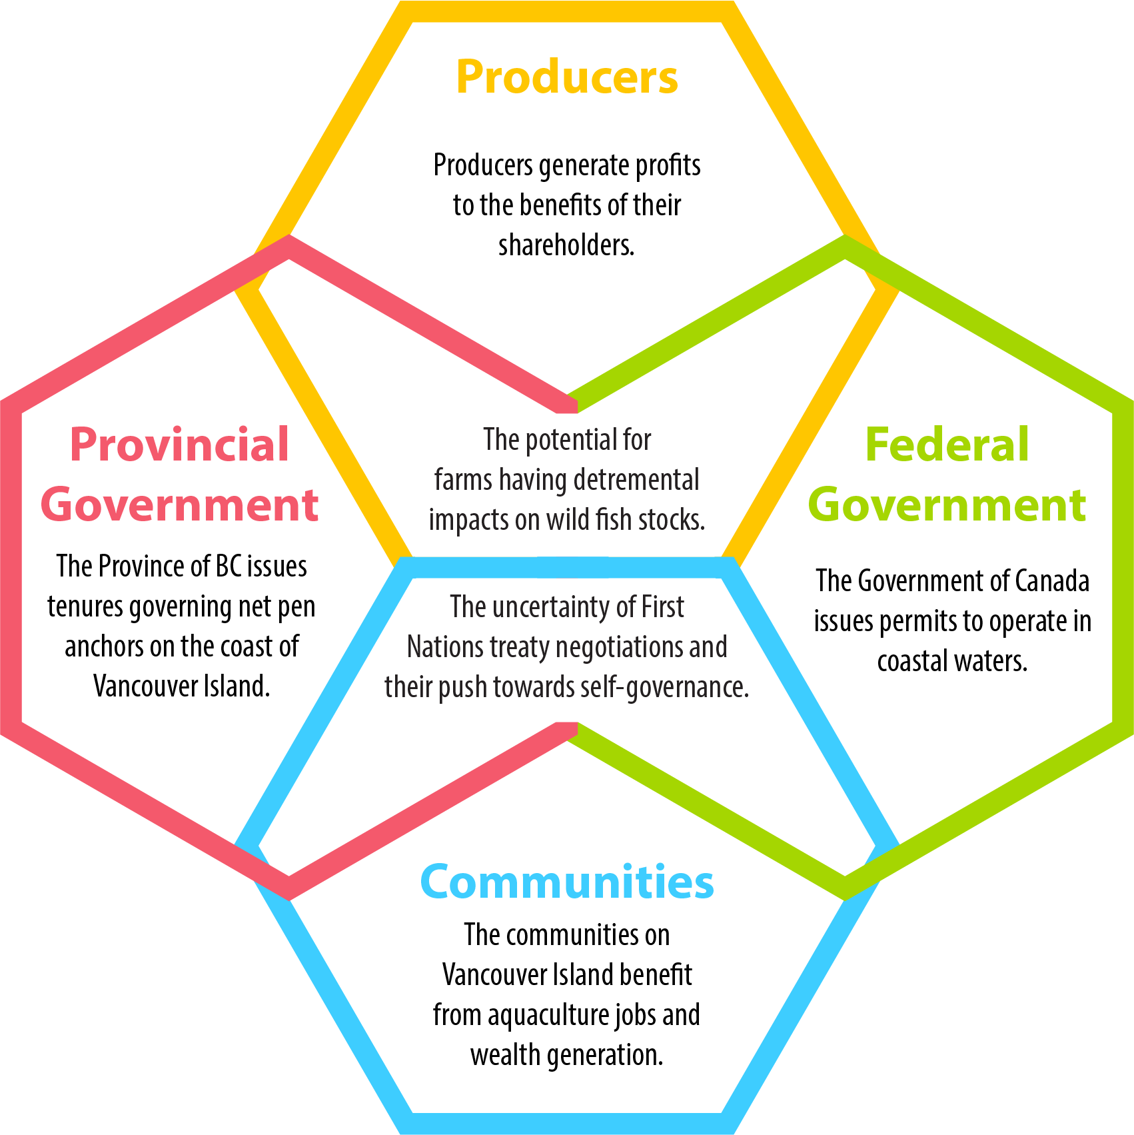
The potential for valued-added wood manufacturing on Vancouver Island is limited by uncertainty in access to raw materials (ie. fibre supply). Specifically, manufacturers on Vancouver Island cannot afford to pay global market rates for timber. Island timber producers command a higher price for their product volume when offered as logs on the international market. There are, however, millions of cubic metres of wood left on the forest floor of Vancouver Island due to the combination of forest practice and provincial taxes in the form of stumpage rates. The Government of British Columbia and the forestry industry are actively seeking solutions so there can be an alignment of incentives to move so-called waste wood to locations accessible by those looking for raw materials. The excess availability of accessible raw fibre is also under some discussion due to access agreements in place between primary producers and the pulp and paper industry.
Figure 2 Diagram of Power Dynamic at play in the VI Forestry Industry.
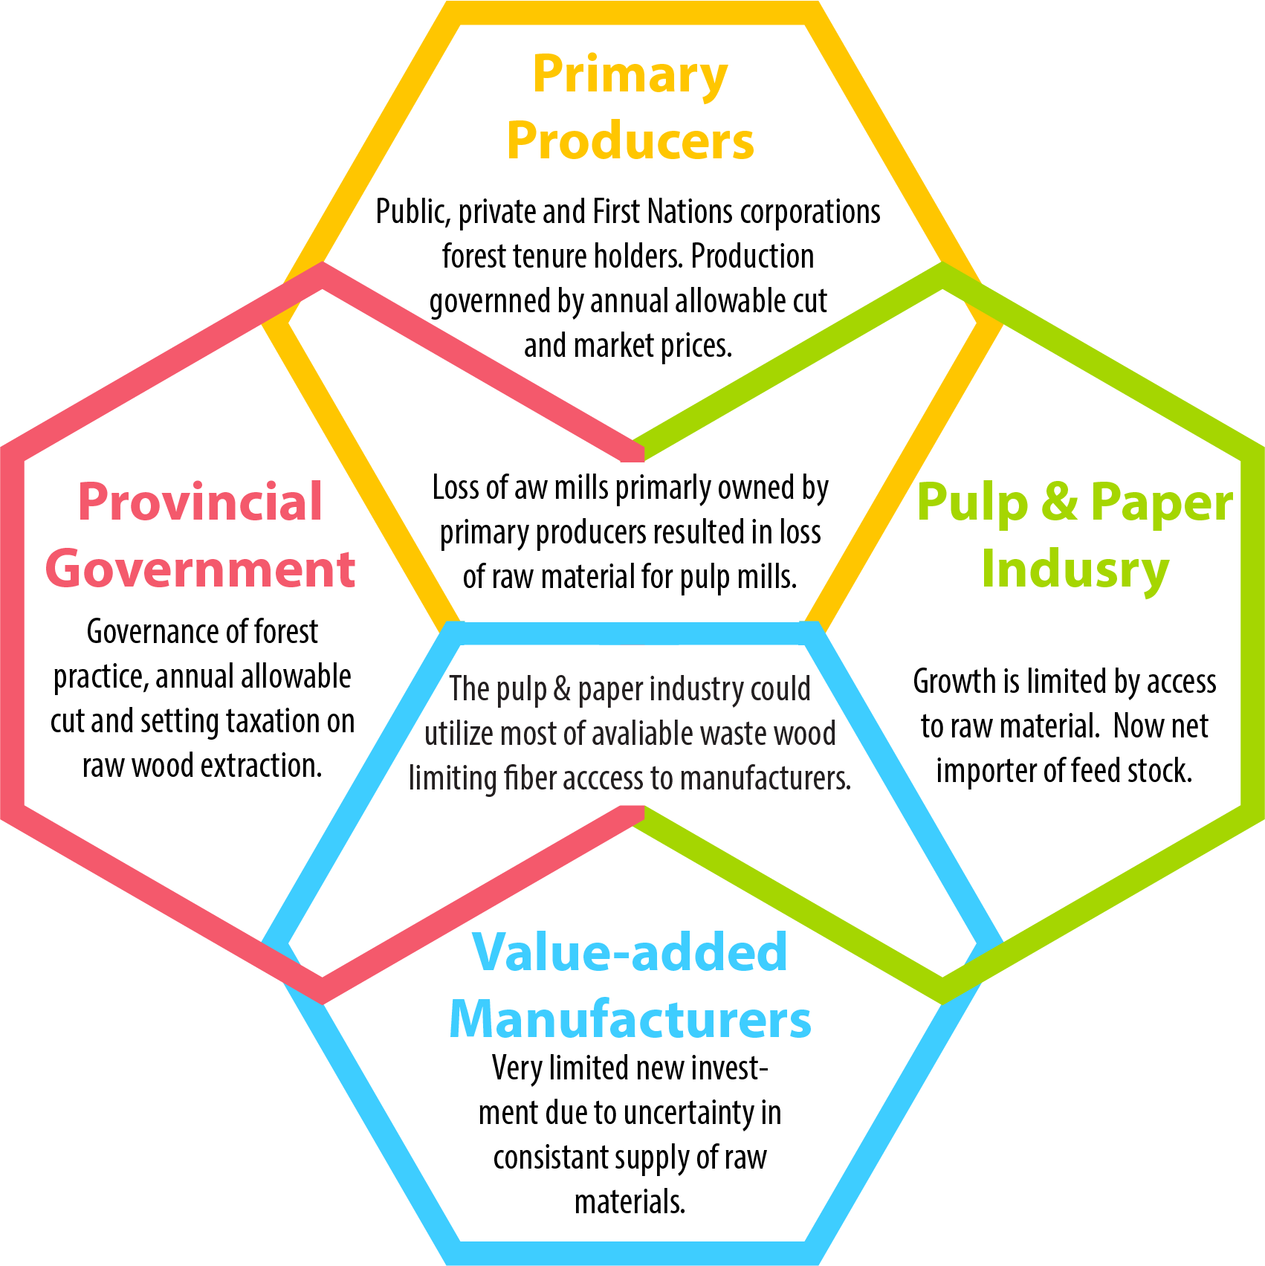

Upon first glance a potential foreign investor in real-estate or property in support of any tourism business may have the perception of risk from uncertainty in treaties and land claim settlement negotiations. The broader discussion of reconciliation between First Nations, government and civil society on Vancouver Island is at the fore of any promotion of community economic development ideas. While uncertainty exists, all parties to that discussion work towards solutions to the larger questions in the long term, while short term opportunities, those with less than a 5-10 year ROI, need to be exploited without delay. To that end, through arms-length corporations, many First Nations on Vancouver Island have a clear and distinct separation between national governance and business-based economic development objectives.

Business Case Introduction
The Government of Canada has recognized Vancouver Island as a Foreign Trade Zone (FTZ). This designation is a recognition that the Island is poised and ready to do business globally. The designation also demonstrates, by the support received from all municipalities on VI for the FTZ application, the willingness of the entire population to embrace global business.
Vancouver Island has the unique potential for significant industrial export growth because of its under-utilized infrastructure capacity. The Island’s heavy industrial past with lumber and pulp mills along the coast, for example, has resulted in long-established social license for industrial activity. It should be said however, that the Island’s population has a deep respect for the natural environment and embraces sustainable growth as an equal partner in economic development.

Transportation
Vancouver Island boasts two of the 18 deep water ports in Canada. Port Alberni on the West Coast and Nanaimo on the East Coast of Vancouver Island act as an excellent conduit to vessels arriving from the Asia-Pacific region and for goods heading west and south from North America. Short-sea connections to mainland Canada and to CN Rail with its terminus at the Fraser River links all of North America with Vancouver Island.
Vancouver Island hosts five airports of varying size and is serviced by many of the global air lines carrying people and cargo. There is also a sizable amount of commercial and industrial land associated with the bigger airports. All of the ports and airports are linked by well-maintained network of roads. The Island Highway connects the communities up and down the Island.
Workforce
The workforce on Vancouver Island is highly skilled and diverse. This is partially due its industrial history, a heritage in the exploitation of natural resources and the influx of new students coming to study at its five post-secondary institutions. While VI boasts low levels of unemployment, thousands of new students enter the workforce every year because Vancouver Island is a considered great place to work. In a 2017 report VIEA highlighted the attraction of new employees to Vancouver Island including:
- Relatively low cost of living
- Island economy is currently stable and growing
- Entrepreneurship shows signs of growth; Small Business increase by 3.2% on Vancouver Island
- High completion rate of Bachelor degree, Diplomas, certificates or trades apprenticeship training
- Amazing opportunities for outdoor recreation
- Our nature-inspired and eco-friendly “Island Lifestyle” is already perceived to be an appealing opportunity by many students and young entrepreneurs

Regulatory Oversight
It has been said that British Columbia is one of the most business friendly Provinces in which to do business. B.C. offers a stable fiscal environment that is cost-competitive with other major North American centers. The Province enjoys tax incentives, competitive personal taxes and one of the lowest corporate tax rates among the G7 countries. B.C.’s general corporate income tax rate is only 12%. When combined with the federal rate, businesses pay a combined rate of 27%. British Columbia offers the lowest personal income taxes in Canada for individuals earning up to $125,000.
BC has the added feature that 98 per cent of our electricity comes from hydroelectric plants. This provides clean electricity to support industrial developments at some of North America’s most affordable and reliable power rates. In addition, the Provincial Government has committed to reducing so-called “red tape” to stream line the intersection of business practice and government oversight.
Municipal taxation has come under scrutiny in the recent past. In a 2011 study of the impacts of taxation on major industrial property points specific to the wood processing industry on Vancouver Island were made:
In British Columbia annual property tax costs are the product of the taxable assessed value multiplied by the applicable tax rates. The taxable assessed value and property classification are determined by BC Assessment, an independent crown agency, legislatively mandated to assess all property throughout British Columbia at its actual value and on a fair and equitable basis. Tax rates are set by the province, municipalities and a number of other taxing jurisdictions.
The BC system is distinctive in that assessment of major industrial improvements (buildings & other components) is based not on market value, but rather through utilization of a costing manual, commonly referred to as the Major Industrial Property (MIP) manual. The costs estimated from the MIP manual are depreciated at legislated annual depreciation rates that range from 4% to 6.5%. In the instance of an operating major industrial plant the annual depreciation is capped at a maximum of 80%. Assessment values are adjusted each year by a cost factor based on trends in changes in reproduction costs of the assessable assets. It is noteworthy that the current major industrial system assessment does not reflect increases or decreases in value as a result of commodity price changes.
Class 4 tax rates are set by individual municipalities. Properties outside of municipal areas are taxed at standardized provincial rates except in Peace River, and these properties are also taxed by the regional districts at rates that differ according to the services provided.
The 2011 study concluded that municipal taxation did not contribute significantly to overall costs, are not a significant factor in decisions on capital purchase or do not affect decisions on reinvestment in existing infrastructure.

Sustainable Aquaculture Business Case

Product Overview
Aquaculture on Vancouver Island consists of the cultivation of finfish, shell fish and the harvesting of aquatic plants.
Atlantic Salmon is the prime finfish farmed in BC while Chinook, Coho and Sockeye are also cultivated. In addition to salmon species, Steelhead Trout, Sablefish, Sturgeon and Tilapia are also farmed. Fish are harvested and processed locally and made available as fresh, frozen and canned products destined for the consumer, both domestic and international. The process of fish farming involves raring of seed stock in land based hatcheries in tanks. At the appropriate stage of maturity, fish are transferred to a closed containment system until such time as they are old enough to be moved to larger pens in open water settings from where they are eventually harvested. The fish are usually transported to processing facilities by truck and boat. In many cases fish pens are in close proximity to land based processing facilities.
Shellfish aquaculture delivers products such as oysters, clams (including Geoducks), mussels and scallops both domestically and for export. Shellfish products are delivered as fresh, frozen or canned. Portions of the fish are prepared for secondary processing. Shellfish cultivation varies depending on the species but all start with wild harvested larvae or from hatchery-produced brood stock. Seed is made available to harvesters at various stages of development depending on the species and are nursed to juveniles where they are transferred to the ocean environment. The growth-environment is a function of the species. Clams are spread over sub-tidal tenures to burrow and mature within the seabed. Mussels grow while suspended in mesh socks in a deep water environment. Scallops are suspended in trays in the water column or seeded onto the seabed. Oysters go through three infrastructure components including a floating water upwelling system, trays and ultimately long-line or by artificial seabed surface cultivation. Harvesting varies depending on species and mode of grow-out. Product is transferred by boat or truck to processing facilities.
Aquatic plant aquaculture on Vancouver Island is in the very early stages of development, with Wild-harvest remaining as the primary means for acquiring inventories. The prospect of high-grading coastal marine areas for controlled production and harvest represents a tremendous opportunity for revenue growth. A multitude of products are derived from aquatic plants including food stuffs and skin care products. Kelps, for example, are considered to be an excellent source of micronutrients, anti-oxidants and dietary fibre, a good source of vitamins, and marginal source of protein. Since humans are unable to digest kelp carbohydrates, kelp are essentially calorie free and fibre rich. Seaweeds, being plants exhibiting a unique biochemical composition, could be exploited for their multifunctional properties in the form of food, energy, medicine and cosmetics and as biotechnological tools.

Business Overview

Market Landscape
Aquaculture is the fastest growing animal-based food producing sector in the world. Farming the ocean is crucial to meeting the world’s food requirements. Aquaculture’s share of global seafood consumption was more than 50% in 2010 (United Nations Food and Agriculture Organization). Key considerations:
- At the current rate of seafood consumption (16 Kg per year – on a per capita basis), many are projecting a shortfall of 50-80 million tonnes of food fish by 2030. If capture volumes remain stable, the assumption is that the aquaculture industry (globally) will make up the shortfall. This means that aquaculture outputs could double over the next 25 years. (This does not take into account farming to produce supplements.)
- Globally, the population is expected to rise from 7 billion to over 9 billion by 2050.
- The amount of arable land available per person globally is shrinking.
- Dietary guidelines published in the Canada Food Guide (Health Canada) recommend at least two servings of oily fish per week in a healthy, balanced diet. This represents double the current North American seafood consumption habits.
- Aquaculture is key to feeding the world’s population in the future.
Figure 4 illustrates the point that, while it may be possible to exploit a sustainable wild fish harvest globally, with the rate of population increase,, aquaculture will be the only source of fish protein that is growing.
Figure 4 Global tonnage of fish harvested by wild fish fishery and aquaculture.
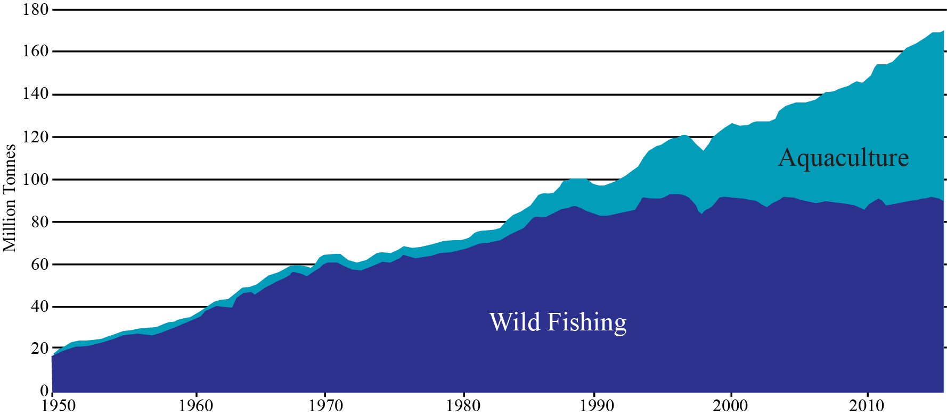
In British Columbia, aquaculture contributes significantly to B.C.'s economy. With its mild climate, good water quality and sheltered bays, the province's coastline is well suited to all forms of aquaculture. The total impact of finfish aquaculture is quite substantial with about $1.3 billion dollars injected into the provincial economy of a direct industry output of $750 million. In British Columbia, aquaculture is considered a mature industry with about 243 aquaculture establishments (2016 numbers) operating in the province. When considering competitive advantage, it is worth noting that when compared with Atlantic Canada the Pacific region produced more aquaculture product by tonne, with about half the facilities.
Table 5 shows aquaculture production in British Columbia for 2016. British Columbia leads Canadian production of salmon, clams and oysters. The maturity of the industry should be considered a competitive advantage when leveraging Canada’s free trade agreements such as the CPTPP and the new CAUSMA.
Table 5 Aquaculture Production in British Columbia for 2016
 | Volume (metric tonnes) | Value ($’000’s)
Salmon | 123,522 | 1,022,127
Clams | 1,962 | 7,076
Oysters | 13,824 | 39,693

As of 2017 there were 48 finfish licenses representing about 41% of all licenses issued in BC. The Island also produces over half of the shellfish farmed in the Province. The average value of shellfish and finfish on Vancouver Island from 2011-2016 was approximately $20M and $500M respectively.
Vancouver Island has become a center of influence and expertise in the areas of:
- Aquaculture services,
- Product research, design and development
- Integration/incorporation of advanced technologies
At the same time, business on Vancouver Island is sensitive to the misperception of diminishing returns, (automatically goods/people/services being transported on and off an island represent diminishing margins). This sensitivity has resulted in an emphasis on maximizing an integrated value chain, where suppliers deliver solutions that are mutually value-added versus a conventional supplier/user/customer relationship. For example, the work being led by North Island College under its 10-year applied research program in Sustainable Aquaculture represents a unique opportunity to capitalize on the synergies between aquaculture sectors (maximizing the value chain) whilst mitigating inherent (real and perceived) challenges of operating on an island. The Sustainable Aquaculture Research Program was initiated in 2013.

Finfish Aquaculture
In terms of finfish aquaculture, members of the BC Salmon Farmers Association produce approximately 76,000 tonnes of salmon annually - growing 58% of all salmon raised in Canada and accounting for 60% of the total landed value of seafood in British Columbia.
Farm-raised salmon is B.C.’s highest valued seafood product, and the province’s second most valuable agricultural crop. With approximately 70% of the annual harvest exported, farm-raised salmon is B.C.’s top agricultural export, going to 12 countries around the world - with 85% of exports destined for the United States, and the emerging Asian market accounting for about 15% of all exports.
Almost 80% of finfish farm sites (95) have Department of Fisheries and Oceans licenses with an expiry date of 2022 with the exception of those in the Discovery area which are on an annual licensing regime. Recent announcements by the Province and the Federal Government extended operations of some companies in the Broughton Archipelago to 2023. These companies also agreed to reduce the number of farms.

Shellfish Aquaculture
Canada’s total shellfish production in 2016 was just over 40,000 metric tonnes with a value of almost $90 million. By volume, mussels and oysters are the primary shellfish species cultured in Canada: in 2016, mussels accounted for 6% of the total national shellfish production while oysters accounted for an additional 35%. Canada ranks 12th globally in the production of both mussels and oysters. In global terms, British Columbia’s contribution to the production of farmed shellfish is small. British Columbia ranks as the 12th largest producer of Pacific Oysters, but only produces 0.12% of the value. Virtually the entire commercial harvest of British Columbia oysters is farmed and the commercial harvest of clams is steadily rising. While production values increase, shellfish farming has not come anywhere near reaching its potential as a key economic driver for coastal communities in British Columbia. There is room to grow!
For shellfish it should be noted that this is an export industry. More than 85% of Canadian aquaculture production is exported; the US is the largest export market for farmed shellfish. British Columbia farms 60% of the oysters produced in Canada and is Canada’s largest producer of farmed clams.

Aquatic plants
Today, the global seaweed harvest had an estimated value of US$6.4 billion a year, and commercial production more than doubled over the previous decade. Today seaweed is used in everything from ice cream to cosmetics to animal feed.
VI has thousands of kilometers of coastline, one of the richest areas in terms of seaweed diversity (over 600 Seaweed species in VI waters), in all of the temperate regions of the world.
World-class, compelling, Island-based research is underway, exploring the viability of growing kelp alongside fish farms, where excess nutrients from a fish farm act as a fertilizer for kelp, supercharging the plant’s growth. Kelp could provide additional revenue, while absorbing much of a farm’s waste, not to mention absorbing planet-warming carbon dioxide.
Companies exploiting the Korean aquatic-plants market are suitable targets for foreign direct investment and represent tremendous potential to bring a global industry to Vancouver Island. In 2015 the total aquaculture production in Korea was about 1.6 million tonnes with the farm gate value of USD 2.16 billion. Seaweed farming production was 1.2 million tonnes in 2015, accounting for 71 percent of the total aquaculture production by quantity and 20 percent in value. That equates to greater than half a billion $US. While Korea has about 2,413 kilometre of coastline upon which to exploit aquatic plants, there is limited room for increased production. The coast of Vancouver Island and adjacent islands is ten times longer and plays host to about 630 species of sea weed.
There are small operations currently harvesting seaweed on Vancouver Island including Canadian Kelp from Bamfield which produces food products and SeaFora from Sooke on the South Island which produces skin care products.

Vancouver Island Competitive Advantage
Vancouver Island offers unique attributes that should be considered global competitive advantages both in terms of geography and the level of maturity, with well-proven infrastructure and workforce. When considering the total available coastline, there exists excess production capacity throughout Vancouver Island. There is a unique oceanic environment with no major river system bringing heavy sediment loads to the coast. Waters are relatively unaffected by agriculture run off or other deleterious effects from poor land use practice experienced in other justifications around the world. For example, anecdotally it has been said that aquatic plant production is very limited along the coast of China due to pollution.
Being an Island, where communities have long exhibited strong cooperation in support of economic development, there is a strong sense of connection and shared values, driving efficiencies and resulting in more integrated value chains. This alignment of incentives maximizes the multiplier effect. As an example, studies into polyculture systems indicate that production of finfish, when grown within a multi-species system including shellfish, seaweed and other benthic organisms, can serve to significantly mitigate the presence of disease and the negative impacts on the surrounding aquatic environment.
Vancouver Island also offers a strategic location as the North American gateway to Asia, with container traffic and international airlines moving via high-grade routes to Asia/Pacific countries. This represents an opportunity to rapidly get product into the hands of the consumer. This is especially true for the trade imbalance between China and North America where there is excess capacity on ships and cargo air craft returning from North America to Asia. The major airports on Vancouver Island have the capacity to expand with a wealth of under-utilized industrial land adjacent to these aerodromes.
For certain sea food species such as sea urchins, sea cumber and geoduck there are well-established markets in Asia. British Columbia suppliers have a deep understanding of this market including processing methods, packaging, time sensitivity (seasonal markets) and other factors that would contributing to greater sales volumes at better margins.

Workforce Considerations
For its relatively small geographic extent, aquaculture production on Vancouver Island exhibits a level of maturity unmatched in other industrial sectors. Four of the world’s major sea food production companies including the world’s biggest, Marine Harvest, have offices and production facilities on the Island. This contributes to the Vancouver Island brand as having high quality and abundant aquaculture production. Along with these well established companies operating here, the type of workforce that these businesses attract results in a wealth of highly-skilled workers. It is quite likely that, as in other sectors, once an individual is employed on the Island they are more likely to remain here through their working life.
Table 6 shows fishing related employment by industry for the years 2014 to 2016. While overall fishing-related employment in BC has declined by ~ 5.6%, employment in aquaculture over the same period has grown by ~14.5%. Overall, farming salmon in B.C. generates approximately $1.5 billion per year to the province’s economy, and accounts for about 6,600 jobs - typically located in rural coastal areas and paying approximately 30% more than the median employment income in BC.
Table 6 Fishing related employment in British Columbia by industry, 2014-2016
Primary Sector (Harvesting) |  |  | Seafood Product Preparation and Packaging (Processing) |  |  | Aquaculture |  |  | Total Employment (Primary Harvesting, Processing and Aquaculture)
2014 | 2015 | 2016 | 2014 | 2015 | 2016 | 2014 | 2015 | 2016 | 2014 | 2015 | 2016
6,008 | 5,308 | 5,206 | 2,519 | 2,392 | 2,645 | 1,450 | 1,480 | 1,565 | 9,977 | 9,112 | 9,416

There exists an excellent opportunity to build capacity in coastal communities as the aquaculture sector grows. Aquaculture can be identified as a pathway to First Nations employment. Particularly as there is a changing demographic in First Nations communities biasing towards youth. Furthermore, aquaculture demands a broad spectrum of skills. Future employment opportunities include higher skill sets such as engineering and data monitoring systems, with digital-mobility mitigating some of the recruiting challenges faced by many coastal communities.
Aquaculture represents a partnering opportunity for First Nations with international or domestic primary producers. This is beneficial not only in keeping community members gainfully employed in full time and long-term jobs, but as equity holders, First Nations business groups will join forces with well-established global companies, building and maintaining business-expertise that can be transferred to many other of their nation’s business interests. As equity holders in successful business, wealth is generated to support other priorities in coastal communities. Perhaps an underestimated advantage in such a partnership is the wisdom that a First Nation carries through its ancestry. With a traditional background and centuries cultivating marine resources, British Columbians can bring new and excellent innovation ideas to the world through their international partnerships. It should be noted that aquaculture is a highly labour intensive industry due to the level of oversight required. Processing facilities also require relatively large workforces.

Market Landscape (Aquaculture Technologies)
Given the production volumes of aquaculture on Vancouver Island there is strong demand for a service industry that can partner in supporting production capacity, and systems design. British Columbia and Vancouver Island in particular has a strong culture of innovation that is very well supported by government research incentives. Programs such as the Scientific Research and Engineering Design as well as the Industrial Research Assistance Program of the National Research Council offer significant monitory contributions to industry. Vancouver Island has several universities and colleges that attract both domestic and foreign students that support a growing technology sector.
There are numerous Island-based technology companies exporting goods and services to South America and Europe. One such company, Poseidon Ocean Systems of Campbell River, provides a full service offering to the global aquaculture industry. The innovation arm of this company is capable of tailoring systems designed to accommodate unique marine settings. As with many other industries, new product research and development is initiated because of a need to deliver improved operational efficiencies or in response to perceived gap in technology offerings. Such is the case with an Island-based aquaculture company, Agrimarine Ltd. Many aquaculture stakeholders predict the future of finfish farming on the open ocean lies with closed-containment systems. Similarly, management systems for ocean pen infrastructure have improved significantly. Against this backdrop, Agrimarine Ltd. has researched and designed a close containment system and has now successfully exported two such systems into Norway.

Value Chain
It is worth considering the distribution of value in billions of dollars across the aquaculture value chain. Figure 5 shows an estimate by OECD indicated the total value is approximately $525 billion. What is perhaps more compelling is that the value of aquaculture is rapidly approaching the value of capture fishing.
Figure 5 Value chain with dollar values for 2006.
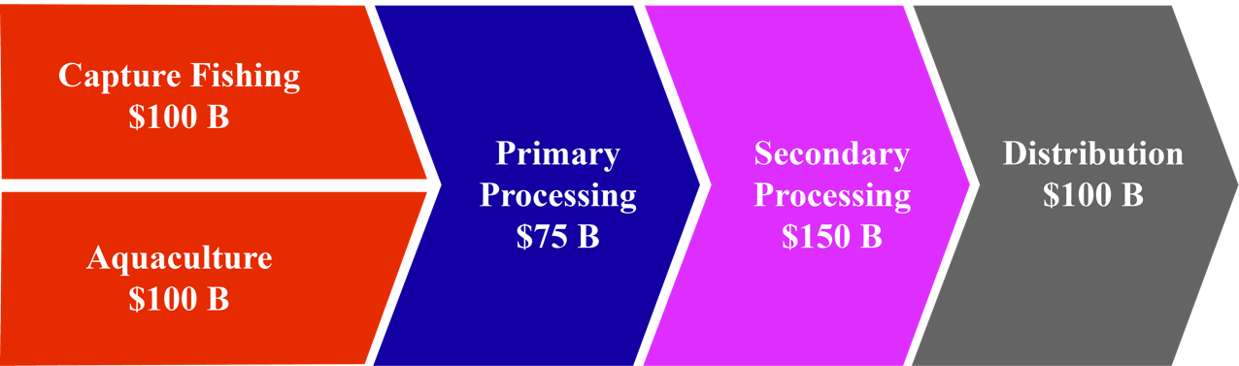
In a recent report on the state of capture fisheries and aquaculture the FAO reported that in 2013 wild caught fish for human consumption equaled that of aquaculture. About 13% of fish processed today is not for human consumption. Furthermore the FAO projected that by 2020 aquaculture for human consumption will surpass the total fish captured in wild fisheries.
Figure 6 Global capture fisheries and aquaculture production, 1990-2030
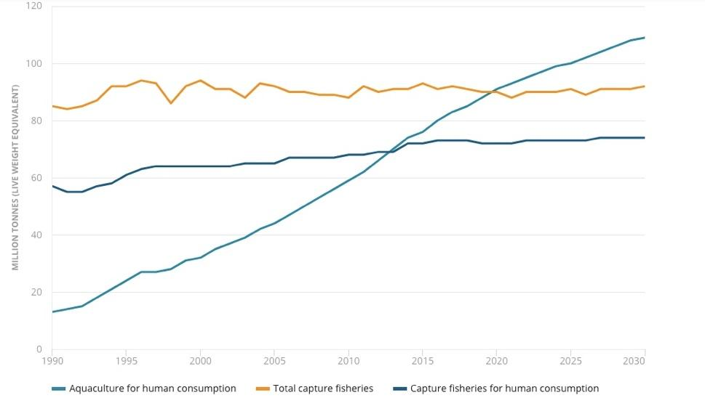

The aquaculture value chain is that of input supply through to the retail delivery of product. Figure 7 shows the aquaculture value chain for the purpose of this Business case. From the Vancouver Island perspective there are key elements that are well suited to its geography, experience and available skill sets. Given our unpolluted coastal water and ready supply of fresh stream water, investment in brood stock and hatcheries will bring returns not only to meet the demands of domestic supply but as a high potential export commodity.
Figure 7 Detailed view of the aquaculture value chain with stars indicating FDI opportunities.
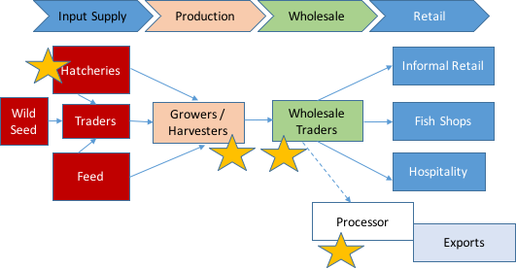

Financial Overview
The financial implications of an aquaculture operation are dramatically different depending on the operations envisioned. For example:
- Initially acquisition of licensing and regulatory approvals are required.
- Most aquaculture operations require an element of land-based facilities for logistics and support services, as such there will be a need to secure land access.
- Processing facilities and cold storage are also required unless third-party processing is contemplated.
- Seagoing equipment must be purchased and assembled.
The absolute dollar value investment is not a practical starting point for discussion of a financial overview. Commentary below on financial elements will help put balance sheet and income statements in a Vancouver Island context.

Capital Intensity
In the aquaculture market today there is an ongoing conversation about methods used to cultivate fish. There is significant public discussion on the use of open net-pen systems versus closed-containment systems in the ocean, versus land-based closed-containment systems. In British Columbia the rule of thumb for a comparison is that for each open pen the capital cost of a marine closed containment system is ten times more and the capital outlay for a land-based recirculating aquaculture system (RAS) is 100 times more. This is somewhat reflective of the land and energy costs involved.
While the cost of recirculating aquaculture systems has come down, in a 2010 study the Department of Fisheries and Oceans calculated the capital cost of open-net aquaculture at $5 million, with a 52% return on investment in the third year, compared with $22.6 million for land-based aquaculture, with a return on investment of 4%.
The investment required for sea weed farming is significantly less. As one individual said “all you need is a rock and a rope”. While the capital for marine-side operation may be substantially less for growing sea weed, specialized harvesting equipment, for example, is required which can cost in excess of $200,000 per harvester. In general, the size of the investment is quite variable depending on scale, type of seaweed, proposed product, and whether you have seed production or processing.

Financing Costs
Financing costs would be commensurate with those from a normal agricultural operation. There would however be a risk premium for a marine setting. This premium should be less than one percent.
Aquaculture is similar to agricultural lending in that more stable market demand, will result in greater price certainty and therefore predictability of cash flow available to service debt. Specialized equipment and buildings, as well water-based assets, may impact the conventional financing capacities of some commercial banks.

Revenue Expectations
There are major global aquaculture players operating in BC and Canada. This is an estimate of key financial indicators from their BC or Canadian operations. These are approximations based on their Q3 performance from published financial information. Grieg Seafoods and Marine Harvest are both Norwegian companies. Another global aquaculture company, Cermaq, operating in BC, is headquartered in Norway but is owned by Mitsubishi Corp. of Japan.
Table 7 Summary of estimated financial indicators of two global companies operating in British Columbia
Company | Grieg Seafoods | Marine Harvest
Revenues CDN$(000’s) | $25,920
EBIT | $1,920 | $ 19,760
Harvest (tonnes) | 2,642 | 12,405
EBIT/Kg | $ 0.73 | $1.60

Expenditures
In Canada there is a move towards implementing a carbon tax. In British Columbia a carbon tax is already levied on industry at a rate of $35 per tonne of carbon dioxide equivalent emissions. The tax rate will increase each year by $5 per ton until it reaches $50 per tonne in 2021. If carbon footprint is a proxy for operating costs in the future it is worth noting that currently, the carbon footprint of raising fish in oceans is far lower than other farmed produce. For salmon it is 2.9 per kilogram, while chicken is 3.4, pork is 5.9, and beef is 30. There is another proxy for cost that provides a different view. Feed is one of the biggest costs for an aquaculture operation representing approximately 50-55%. The feed conversion ratio (FCR) the ratio of feed to desired output. For salmonids the FCR is 1.2 – 1.2 while for pork it is 2.5-3.0.
When comparing operating costs for marine open or closed systems it is clear that closed containment systems are subject to less risk to their biological assets from surrounding environmental elements. For example, losses due to oxygen depletion, algae and seals take a toll on stock. One local expert suggested that a closed containment system is akin to a stock management system as opposed to an environmental management system. Aquaculture is a labour intensive industry with a mix of skills required. Minimum wage labour in British Columbia is $12.65 per hour. Average wage of a Marine Technician in Canada is $32.50 per hour and a Mechanical Engineer would make about $70,000 per annum.

Marketable Waste Wood Business Case

Product Overview
In a 2017 report on value-added wood manufacturing, VIEA suggested there were viable business opportunities for new ventures. One challenging aspect to the discussion was the availability of raw materials. This non-market force was discussed earlier and suffice to say it is being addressed. The discussion however, did illustrate a compelling opportunity involving the utilization of wood material that is either overlooked or left on the forest floor. This fibre is generally not available as feed stock to any further processing as pulp and paper, small cut dimensional lumber, or value-added manufacture. As a result of this gap, there is a case to be made for generating wealth from activities involved with extracting from the forest and thereby generating a supply of marketable waste wood.
One such opportunity involves exporting wood to China for use as raw material to the wood packaging industry. The global wood packaging material market sometimes referred to as Non-Manufactured Wood Packing (NMWP) or Solid Wood Packing Material (SWPM), is part of a hardwood and softwood sector. Wood packaging materials are different from wooden products such as plywood, particle board, oriented strand board, veneer and wood wool. These are created by using glue, heat, and pressure or a combination of techniques. Wood packaging materials are used in supporting, protecting, or carrying goods. Different examples of wood packaging materials include pallets, crates, boxes, cases, bins, reels, drums, load boards, skids, pallet collars and containers.
Depending on product type, the wood packaging materials market is segmented into Wooden Pallets and Wooden Containers. The main advantage of using wooden containers and pallets for packaging is that it can be reused and in case of damage, repaired for reuse. Use and reuse can be for up to 4-5 years, with diverse applicability for packaging in areas such as of food & beverages, grocery items, telecommunications, dairy, automotive, chemicals and construction, to name a few.
Increasing demand for industrial-product packaging has brought variety of rigid and flexible packaging designs to the market. Packaging is an important contributor to overall product safety. It allows clean transition with less interference of human contact, while providing advantages in the sale process. For shipping of larger consignments, rigid packaging materials like wood are used.
A value-added wood packaging product that can be exported from Vancouver Island is dimensional lumber cut to minimum sizes of 90 millimeters square by about 2 metres in length. Unlike other wood products, timber destined for wood packaging is not subject to moisture-content or species requirements. Recovered Marketable Waste Wood destined for foreign packaging manufactures can simply be pretreated with spray to counteract the risk of mold growing during shipment. The critical factors in using VI waste wood for export are assembling, milling (sizing), and containerizing for ready shipment to China.

Business Overview
Overall annual US-based pallet industry production in 2016 was estimated at 849 million wood pallets (508 million new and 341 million recycled). This output represents an overall 14% (22% increase for new pallets and 5% for recycled) increase compared to 2011 results – previously the most recent data available.
Lumber consumption in pallet production is estimated to range between 4.1 and 5 billion board feet in 2016, with a ratio of 45% hardwood and 55% softwood. Pallet production uses 43% of hardwood and 15% of softwood produced in the US.
The Timber Packaging and Pallet Confederation (TIMCON) has warned that shortages in the supply of small logs have reached an unprecedented level due to the ongoing combination of high global demand and supply scarcities. TIMCON is a not-for-profit trade association representing the UK's interests in wooden packaging. The scale of the business is huge. Every year over 1.5 billion pallets are produced worldwide, using approximately 60 million cubic metres of timber.
As reported in an April 2018 article about the UK pallet industry, an estimated 42.5 million new pallets were produced in 2016, up 5.6% compared with 2015. In the same period, an estimated 41.4 million pallets were repaired, up 6.2% over 2015. Total UK turnover from manufacturing pallets was £268.1 million; while turnover for repairing pallets was £90.2m. There is however, a looming crisis in the UK timber packaging industry as a result of the following:
- High demand globally, in particular China.
- Scandinavian timber flowing primarily to the U.S. construction market.
- An unfavourable exchange rate caused by Brexit.
- Baltic supplies down.
- Good UK demand.
- Subsidized biomass industry buying up small logs previously destined for the the packaging and pallet sector.
- Adverse and changing weather, which is affecting the harvest of home-grown timber.
Of note from this list is that global demand supports the premise that increasingly, China could be looking towards British Columbia for a non-traditional supply of wood for it’s packaging sector. Supplying marketable waste wood from Vancouver Island could be quite lucrative however, the key success factor will be the ability to ensure there is a sustainable and exportable supply.

Waste Wood Availability on Vancouver Island
Waste levels have been increasing significantly over the last decade. The trend for cutting on the Island is for more remote sites. There is also a higher transportation cost resulting in more wood being left on the ground. There is a move towards more intensive forest practice and reducing the quantity of waste wood left in the forest. Not only will waste wood removal provide access to raw materials for the pulp and other industries, but it will reduce the threat of fuel buildup that contributes to the forest fire hazard. The removal of waste wood represents a positive alternative to the current practice of waste-pile burning. Non-burning alternatives have the advantages of reducing CO2 emissions and improving air quality in communities close to burning activities. Quality of life will be improved and a value-added manufacturing solution will improve availability and types of jobs. Universally, stakeholders have expressed a strong desire to move away from current practices.
Waste wood accounts for approximately 2.6 million m³ per year on Vancouver Island however, competition for this raw material is stiff, with the pulp and paper industry indicating a shortage of feed stock. At this time Vancouver Island pulp mills are net importers of pulp.
There is an overall shortage of fibre supply not only in British Columbia but worldwide. In BC, the Mountain Pine Beetle, wildfires and harsh winters have dramatically reduced timber availability. The wood packaging industry freely utilizes beetle kill and burnt wood.
There exists a strong mandate within Provincial Government regulators to manage and make available waste wood. The Ministry goals include identifying opportunities for business-to-business discussions. To this end they have encouraged communication between the primary harvesters and secondary users, recognizing that a market-based approach will lead to the most efficient solutions for removing waste wood, and making it available for further processing.
In June of 2018 the Government’s District Forest Manager for the South Island created a pilot project called the “South Island Forest Recovery Zone (FRZ)”. FRZ’s are identified as areas where residual fibre has potential to be harvested economically, and where fibre demand is strong. Under this pilot program, the District Manager can issue a fiber recovery license to a party other than the primary harvester. The policy is intended to encourage discussion and perhaps action towards removing waste wood on Southern Vancouver Island. It is also hoped that the actions will serve to maximize the efficiency of the annual allowable cut (AAC).
The forests on Vancouver Island have numerous owners with various rights to cut timber. More than 95% of standing timber on the Island is owned by the Crown meaning that harvesting rights are largely controlled by the Provincial Government. The majority of timber is available to be harvested either by holders of Tree Farm Licenses (TFL’s) or through First Nations treaty lands. Significantly lower numbers of lumber sellers on the Island means that some industries are dependent on logs for feed stock. They are at a competitive disadvantage in accessing the raw materials compared to their mainland counterparts. It has been said that labour deregulation or decreasing the influence of trade unions has opened the market to more competition yet the value chain is very restricted because of lack of diversity in licenses to cut timber. The market dynamic of the forest industry on Vancouver Island is dramatically different from that of mainland British Columbia. While more than 90% of the Island’s trees grow on Crown land, tree farm licenses are held by very few players.
The immediate and perhaps lowest risk method for accessing waste wood, may lie in the ability to access fibre on private lands including First Nations properties. This could have the added advantages:
- Creating new and sustainable employment opportunities in First Nations communities
- Private sector opportunities being less susceptible to non-market forces
- Private sectors opportunities being easier to bring to market, and more suitable for demonstrating the long term sustainability of marketable waste wood ventures.
- The collateral advantage of bringing new opportunities to coastal communities may be the improvement of the social license of the Forestry Industry.
Value Chain
Figure 8 represents the marketable waste wood value chain for the purpose of this business case. As mentioned the likely best supply of wood is from private lands including First Nations holdings. Therein lies the fewest barriers to harvesting. Value can be realized by the primary license holders and those sub-contractors set to harvest. Included could be stewardship goals and perhaps increase monetization of standing timber assets.
Figure 8 Marketable waste wood value chain with stars showing potential partnerships through FDI.
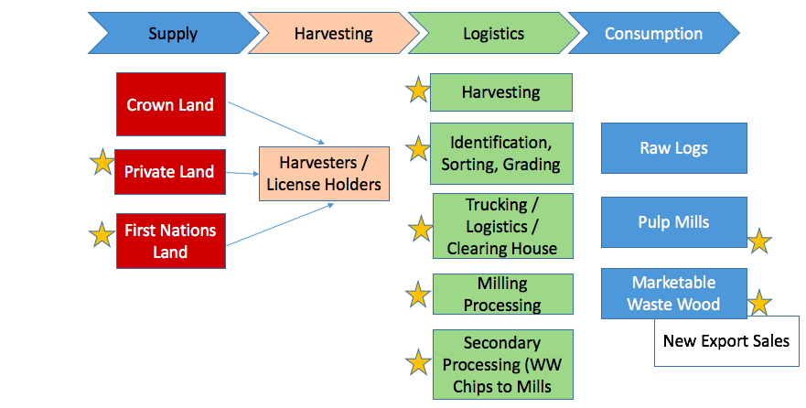
The value chain could be improved over existing practice with new/advanced technologies for species identification, sorting and grading. This would encourage the development of new skill sets with a broader community employment opportunity. Equipment that is smaller than traditional log hauling vehicles would be required for Marketable Waste Wood transportation. There has been the suggestion that smaller trucks would be less efficient in getting the wood to a sorting facility. Perhaps new approaches such as bins loaded at the cut blocks are necessary to mitigate inefficiencies.
There may also be a need for new approaches to MWW sizing in the value chain. The wood can be processed using smaller, perhaps even portable mills at the cut block. A key necessity is the value in centralized log sorts to act as a clearinghouse where the timber can be sorted based of value for specific secondary processing. As stated earlier, the pulp and paper industry is eager to absorb as much raw material as available due to the feed stock shortfall on the Island. An integrated value chain approach could support a win-win situation where, for example, the wood packaging manufacturer could make the residual chips from milling available to the Islands’ pulp and paper companies.

Financial Overview
The MWW opportunity starts with the assumption that feed stock is available. An investor would have to cover items such as the survey to get a rough order of magnitude of the amount of wood available. The BC Government regularly surveys the volume of waste wood from logging operations. Those estimates are published on a regional basis. It is likely a better estimate is required. There are survey technologies available today, drones for example, that could carry payloads such as cameras or LiDAR (high resolution laser mapping tool) to assess size and species. A level of research and development will be necessary before full deployment is likely. The BC Government has suggested it would be supportive of such research.
It is also expected that the investor would have to cover extraction, transportation and milling. There are numerous companies on Vancouver Island that are capable of this contract. In addition, expertise exists within the Island’s First Nations communities to do this work. Skills training is available.
The investor would also be required to cover logistics and export. As suggested earlier, the port infrastructure on the Island is considerable and available. A ballpark estimate for shipping a 40’container of wood to Asia is about $1,500.

Performa Income Statement
Table 8 is a proforma income statement used to illustrate the breakdown of key elements in calculating the flow of revenue and expenses for a theoretical marketable waste wood enterprise. This is an end-to-end venture meaning the company sources the raw material. That being residual wood following logging operations on Vancouver Island in the forest. The company either mills the wood onsite using portable wood mills or transports the material to a log sort. In addition to burn piles and usable material remaining at the top of the stump being acceptable, limbs meeting a minimum dimension objective are also useable to the end client. Dimensional cuts are containerized and transported to a port where they are shipped. End clients in China have been identified.
The revenue number expressed in Table 8 is derived from a price paid per m³ in 2018. The assumption is that 10,000 m³ per month is sold at a price of $225 per m³. Estimates are, that due to the growing global shortage of wood-for-packaging materials, Chinese factories are willing to purchase up to 20,000 m³ per month. Cost of sales and operating expenses were derived from Industry Canada’s baseline Financial Performance – Canadian Industry Statistics for forestry and logging companies. The results indicate a net income of 19% on a gross profit of 76%. One BC enterprise is reported to have shipped 12,000 m³ of waste wood into this market space in 2018.
Table 8 Proforma income statement for a generic enterprise selling raw material into the wood packaging manufacturing industry in Asia.
Revenue (10,000 m3/mo @ $225/m3) | $ 27,000
all values in 000’s
Cost of Sales
Labour | $ 1,620
Wood | $ 960
Transportation | $ 3,780
Total | $ 6,360
Gross Profit | $ 20,640
Gross Profit % | 76%
Operating Expenses
G&A | $ 11,880
Labour | $ 4,860
Operating Income | $ 3,900
Net Income Before Tax | $ 5,000
% of Revenue | 19%

Potential Partner Opportunities
One Chinese company with the potential to partner on the value-added manufacturing of waste wood is Shanghai Xintonglian Packaging Co., Ltd. They engage in the production and sale of packaging products in China and internationally. The company offers paper, wood, and plastic and cushioning packaging products. It also provides iron box packaging products, hollow board packaging boxes, stickers, desiccants, shockproof labels, shockwatch tilt displays, and single angle anti-tilts. In addition, the company offers inventory management and packaging services. The company was formerly known as Shanghai Xinliantong Packaging Materials Company and changed its name to Shanghai Xintonglian Packaging Co., Ltd. in June 2011. The company was founded in 1999 and is based in Shanghai, China. This company currently buys wood from the BC interior.

Cultural and Eco Tourism Business Case

Product Overview
Tourism is loosely defined as various activities of people which include travelling and staying in places different from their usual environment either for business or leisure purposes. Vancouver Island has a global brand as the place to see natural beauty at its finest. The Cultural and Eco Tourism products considered for targeted foreign direct investment are tourist destinations with fundamental assets such as properties, equipment, or amenities, where an appropriate injection of capital and/or expertise have strong potential to assist with growth and development.
Key components of the tourism industry include tourist destinations and sites, accommodation and food, transportation, tour guide/operators, travel agents and travel information services. In the broadest sense as given by BC’s hospitality industry’s workforce portal, GO2HR, this sector is comprised of:
- Hospitality (accommodation and restaurants),
- Arts, entertainment and recreation, and
- Transportation activities relevant to the movement of tourists and domestic travelers.
Accommodation and food and drinking services comprises establishments primarily engaged in providing short-term lodging and complementary services to travelers, vacationers and others, in facilities such as hotels, motor hotels, resorts, motels, casino hotels, bed and breakfast accommodations, housekeeping cottages and cabins, recreational vehicle parks and campgrounds, hunting and fishing camps, and various types of recreational and adventure camps. This sector also comprises establishments primarily engaged in preparing meals, snacks and beverages, to customer orders, for immediate consumption on and off the premises.
The arts, entertainment and recreation sector comprises establishments primarily engaged in operating facilities or providing services to meet the cultural, entertainment and recreational interests of their patrons. These establishments produce, promote or participate in live performances, events or exhibits intended for public viewing; provide the artistic, creative and technical skills necessary for the production of artistic products and live performances; preserve and exhibit objects and sites of historical, cultural or educational interest; and operate facilities or provide services that enable patrons to participate in sports or recreational activities or pursue amusement, hobbies and leisure-time interests.
The tourism and hospitality sector only includes subsectors of the transportation industry that provide water, air, public transit, taxis and sightseeing transportation. Suffice to say there is a substantial multiplier impact on local communities.
For purposes herein, cultural and eco tourism are combined. They represent visitors from regions outside Vancouver Island travelling for the purpose of immersion in a specific culture, most likely indigenous, or to spend time in natural, relatively untouched surroundings. This example of content from a Vancouver Island travel website sums up the rationale for VI tourism:
Learn about the unique culture and history of the Island’s First Nations people as you listen to one of the many stories in the Living Languages interactive exhibition at the Royal British Columbia Museum in Victoria. Or learn about the Island’s First Nations Peoples’ role in local stewardship, conservation, and development, as well as their history, culture, and way of life as you paddle a traditional dugout through the waters of the Pacific Rim with a guide from the Nuu-chah-nulth community.
Dine on freshly caught Dungeness crab or salmon with the Ucluth First Nation, near Tofino, and then head up Island to take refuge, watching the pink salmon gather where the Cluxewe River joins the Broughton Strait before heading upstream to spawn. In Courtenay, discover the beauty of locally carved masks, jewellery, and woven cedar baskets, or wander through Thunderbird Park in Victoria to see one of the world’s finest collections of authentic totem poles.
A tremendous opportunity exists for First Nations on Vancouver Island to share their lands and stories of their culture and ancestry with visitors while at the same time supporting sustainable growth in their communities and the communities at large on the Island. The business case therefore seeks strategic financial investment in infrastructure with added collateral gains of global-tourism expertise and capacity development.

Business Overview
There are 528 Vancouver Island businesses listed in the BC’s tourism industries HR database, Go2HR, formally known as the Hospitality Industry Education Advisory Committee. These business types range from transportation services, to accommodations, and food and beverage. There are also a range of goods and services offered while guests are visiting. These include activities such as nature sightseeing with a range of participation difficulties of static nature including museums and sites of cultural significance, to extreme trekking. Educational or wellness activities ranging from workshops to spa or physical and mental wellness sessions are becoming quite important in destination tourism.
Cannabis Tourism
In light of recent legislation, cannabis tourism should be mentioned as a plus-one in the tourism industry on Vancouver Island. With the legalization of the cannabis industry in Canada, this country will be seen as a tourist destination where it is legal to consume cannabis products. It is worth reviewing the impact of legalization that was experienced in Colorado and Oregon. One year after legalization in Colorado, a study of visitors found that 4% of people visited the state exclusively for cannabis, 8% shopped at a cannabis retail store, and 23% of visitors were partially motivated to visit the state because of its legalization. The logic is that if 8% of visitors were not going to purchase at a store then perhaps they were consuming as part of hospitality and tourism experiences . If the numbers on Vancouver Island are equivalent, then about 15% of new tourism business on the island means an increase in tourism related revenue of about $255 million using 2014 numbers.
Any attempt to exploit the opportunity of Vancouver Island as a global tourist destination has to involve leveraging the Vancouver Island brand. There are examples of successful branding from this region. The Haida brand of culture and art is known worldwide and is synonymous with West Coast villages and rainforests. The Vancouver Island region is the perfect mix of urban life, small town charm, historic architecture, world-class museums, and coastal galleries.
Vancouver Island makes up the second largest share of tourism establishments in BC at about 3000. Growth in this number is steadily increasing as more visitors discover the charm of the coastal lifestyle. Many of the 20,000+ employees in this industry on the Island are baby boomers.

Market Landscape
Global Demand for Tourism
According to the United Nations World Tourism Organization (UNWTO), 2017 recorded the highest growth in international arrivals in seven years. After eight consecutive years of steady expansion in the 4–5% range, year-over-year growth of 7% in 2017 marked a new record since the global financial crisis in 2009.
UNWTO also predicts growth in 2018 around the 4% range, and more modest growth of 3.8 % until 2020. This is good news for ITAC as a significant driver of this growth is visitor’s search for authentic visitor experiences which provide real benefits to indigenous peoples and nations. There are currently 370 million indigenous peoples in the world, many looking for new economic opportunities and to whom the tourism industry often turns to assist with leading restorative and sustainable tourism practices. As 2017 was the International Year of Sustainable Tourism, development tourism leaders viewed this as a key opportunity for putting indigenous tourism high on the international tourism agenda.
According Indigenous Tourism Association of Canada, international arrivals for Canada are at an all-time high. Research has also shown visitors to Canada are higher-yield and more internationally diversified, leading to greater revenue for the visitor economy. This lines up with conversations with Vancouver Islands First Nation business who expressed a desire to attract premium visitors (those willing to spend more per capita) to mitigate shortfalls in capacity that would exist with higher volumes of tourists.
All stakeholders in indigenous tourism in Canada are after a bigger piece of the global pie. Targets for indigenous tourism in Canada for 2016-2021 include a $300 million increase in annual Canadian GDP from indigenous tourism. Workforce targets include a total of 40,233 indigenous tourism workers by 2021 with 50 new indigenous tourism operators at export-ready status by 2021.
There also exists opportunity to leverage the Comprehensive Economic Trade Agreement between Canada and Europe (CETA) in attracting tourists seeking indigenous experience. Experience indicates that large numbers of German travelers are fascinated with tourism experiences involving North American First Nations cultures. More than 5 million German long-haul pleasure travelers intend to visit Canada in the next two years. In a 2017 survey of German Tourism, 24% of those thinking about a visit to Canada claimed an “anchor” activity (important enough that they would base an entire trip around that activity) as “aboriginal culture and tradition”. It has been suggested that this is the result of various reasons including:
- Forests in Germany are meticulously manicured and, with the exception of a handful of national parks, nature is extremely ordered and unsightly undergrowth is removed.
- Wilderness is rare and where it does exist, solitude is nearly impossible. German forests are far from wild. They’re heavily groomed and extremely orderly. And where there is real forest there is almost never solitude.
There is also quite a number of direct routes between Vancouver Island and Germany. The Vancouver to Frankfurt air route is very popular with daily flights. Germans are accustomed to long days in summer and short days in winter. The idea of being “north of 60” is perfectly normal for most Germans.
Travelers from the United States are also set to increase. Particularly those seeking a true cultural experience. According to a report published in 2017 by the Indigenous Tourist Association, authenticity is the key to attracting visitors from the United States. US travelers indicated that they prefer one-on-one interaction with aboriginal people, in small, intimate groups. They also want to be actively involved in learning about cultures, traditions, arts, food, storytelling, history and are interested in participating in adventure, both physical and mental. It was clear that they are looking for unique experiences. The survey also suggested that there is an actively engaged segment of travelers in the US positively predisposed toward indigenous cultural experiences. At the same time, awareness and understanding of indigenous tourism in Canada is low.
US travelers who provided insights as to why Canada may be a destination for cultural tourism stated that their impressions of indigenous tourism in the US are often negative. American travellers feel guilty about how the US has historically treated indigenous peoples in the past and continues to treat them today. For some, this contributes to a perception that indigenous people in the US may not truly be interested in interacting with tourists or sharing their culture with them. Americans sense that an indigenous experience in Canada could be more authentic than in the US.
With respect to Asian travel it is estimated that by 2036 there will be 7.8 billion people traveling by air, with almost half of travelling to, from, and within Asia-Pacific. There does not seem to be a shortage of tourists wishing to visit British Columbia. The market is somewhat limited by available workforce. In British Columbia, five industries will account for about half of the total job openings projected over the next 10 years. They are:
- Health Care and Social Assistance (148,400 job openings; 16.4 percent of total job openings)
- Professional, Scientific and Technical Services (106,200 job openings; 11.8 percent of total job openings)
- Retail Trade (82,300 job openings; 9.1 percent of total job openings)
- Accommodation and Food Services (61,000 job openings; 6.8 percent of total job openings)
- Finance, Insurance and Real Estate (59,700 job openings; 6.6 percent of total job openings)
Table 9 shows projections of tourism and hospitality industry job openings in British Columbia for the next decade. Vancouver Island is listed as second only to the Lower Mainland in expected job growth. If the cultural tourism business case is vested largely in the First Nations communities then it becomes important to consider First Nation employment.
Table 9 Tourism and hospitality job openings by region 2017-2027
Region | Job Openings
 | 2017-2022 | 2022-2027 | 2017-2027
British Columbia | 56,200 | 55,143 | 111,343
Mainland/Southwest | 36,547 | 37,529 | 74,076
Vancouver Island/Coast | 8,740 | 8,365 | 17,105
North Coast/Nechako | 632 | 641 | 1,273
Carriboo | 1,079 | 996 | 2,075
Kootney | 1,323 | 1,037 | 2,361
Northeast | 681 | 819 | 1,499
Thompson-Okanagan | 7,197 | 5,757 | 12,954
The potential for First Nations tourism to be a large part of British Columbia’s overall tourism product mix has been a recognized for many years. Rates of First Nations participation in tourism and hospitality employment has however, typically been lower than the proportion of indigenous workers in the total provincial workforce. That is starting to change as approximately 3.2 per cent of the tourism sector labour force in BC is now indigenous. The tourism and hospitality industry is twice as reliant on young workers as other sectors in the province, and the indigenous population is relatively young. By 2026, the percentage of First Nations populations 14 years old and younger is projected to be 24% and 35%, respectively, compared to 15% for the total Canadian population. This, combined with the strong growth of indigenous tourism product, means there is potential to further increase First Nations participation in the BC tourism labour force, particularly among youth.
Vancouver Island makes up the second largest share of tourism establishments in BC at about 3000, and growth in this number is steadily increasing as more visitors discover the charm of the coastal lifestyle. Many of the 20,000+ employees in this industry on the Island are baby boomers. A 2017 estimation of indigenous tour operators on Vancouver Island indicated that more than 50% of those in the industry were involved in the delivery of accommodations or outdoor adventures.
Figure 9 Indigenous Tour Operators on Vancouver Island by type in 2017

There are, however, workforce challenges to be mitigated in the near term, perhaps using government support mechanisms such as the temporary foreign workers programs. In terms of foreign direct investment, where possible, it is natural to leverage free trade agreements. The Comprehensive and Economic Trade Agreement that Canada shares with Europe has language supporting unlimited travel for individuals seeking to develop foreign investment. An example of the language is as follows:
The Key Personnel: The Key Personnel article applies to intra-corporate transferees, investors, and business visitors for investment purposes. The article prevents Canada and the EU from limiting the number of key personnel entrants through either numerical standards or economic needs tests. The Parties may also not require work permits for business visitors for investment purposes, provided individuals not engage in direct transactions with the public or receive remuneration from a source within the host Party.

Tourism and Hospitality Value Chain
Figure 9 illustrates a tourism value chain. The tourism value chain, like others, has direct and indirect elements. These are the main drivers of value extraction as each is delivered to the end customer. The multiplier is in the goods and services delivered. The indirect portion of the value chain are the numerous business that support tourism and through which the community hosting the enterprise derives value. While Figure 9 depicts a typical value chain and exhibits little difference from any worldwide tourism sector for cultural tourism specific elements may be deemphasized while others may be a closer fit with Vancouver Island community values.
Figure 9 The tourism value chain with stars indicating initial FDI opportunities.
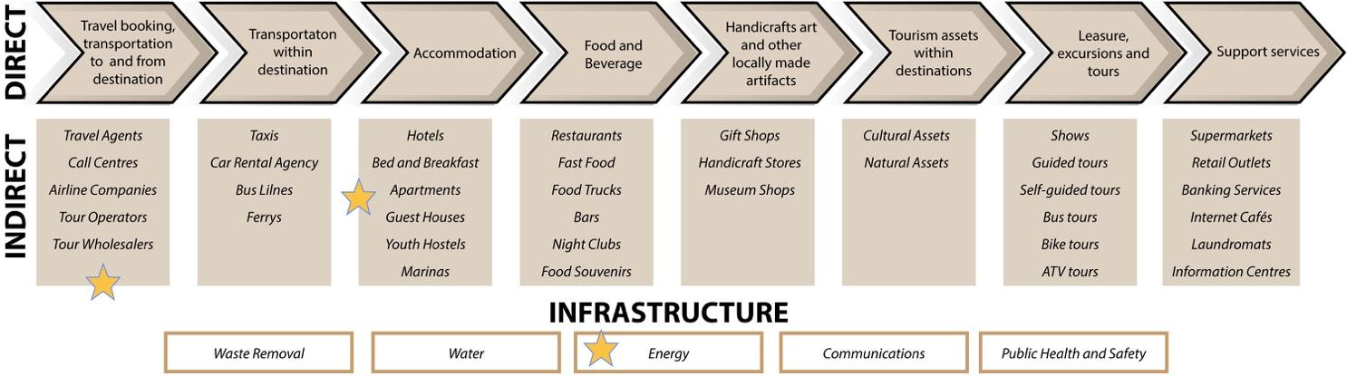

Before value can be derived from cultural tourism, visitor infrastructure must be in place. Investments in capital infrastructure must be made prior to building out the sector in a destination. However, the value derived from the activity, once a threshold of visits has been accomplished, will support future infrastructure capacity building.
Existing regional capacities for delivering tourism on Vancouver Island are quite varied. Tofino is a prime example of a tourist destination with an international brand. Tofino may be oversubscribed as a destination to the point that the negative impacts of tourism are being openly discussed. The same could be said for Victoria where there exists a chronic shortage of hotel rooms in peak season. Such challenges for these specific areas provide an opportunity for a broader range of tourist destinations on other parts of the Island. Places such as Courtney/Comox having dual access to ocean and mountain from the same resort location should be considered prime for investment in tourism. Vancouver Island has a vast amount of real estate and coastline with tremendous potential for foreign direct investment supporting cultural tourism. Tourists from Europe and Asia could be strategic targets for initial consideration. It is worthy to consider investment from for-profit entities specializing in global tourism, where existing supply chains and networks can be leveraged to help in delivering sustainable visitation. There are major tourism consultants who could supply names of such target enterprise.
The other obvious choice in seeking FDI is in building large accommodation infrastructure. While such ventures can be accomplished with domestic or even local investment, having an international partner with global outreach will result in more visitors if their network is leveraged. An example of a destination hotel delivered locally is the Kwa’lilas Hotel in Port Hardy that was built by the k’awat’si Economic Development General Partner Corporation, a distinct entity reporting to the Chief and Council, Gwa’sala-‘Nakwaxda’xw Nations.
Another potential target for FDI in cultural tourism is in the infrastructure needed to support a community’s long-term strategic plan for tourism. Many remote communities on Vancouver Island are well suited to destination tourism. These communities need significant investment in infrastructure to support visitors. This represents a potential opportunity for an foreign direct investor. Investment in renewable energy as a fundamental component of an infrastructure build-out could be considered. Wind power or wave energy for example, might be suitable for supplying tourism ventures on Vancouver Island’s West Coast. Certainly hydroelectricity is still considered a renewal energy supply and there are many run-of-the river hydroelectric projects delivered by small communities. This sort of energy infrastructure may be suitable for FDI.

Financial Overview
It is not appropriate, nor particularly valuable, to define a financial overview for the major elements that make up cultural tourism. It may be useful to discuss the considerations necessary when thinking about the size and complexity of a cultural tourism investment on Vancouver Island.
Accessibility of the destination from major airports is usually a prime consideration. Vancouver Island is serviced by many airports and water aerodromes (Table 10).
Table 10 List of Major Airports and Water Aerodromes on Vancouver Island
Facility | Type | Designator | Regular Schedules
Nanaimo | Airport | CYCD | VI and Eastern and Western Canada, International Charters
Victoria | Airport | CYYJ | International Destinations
Port Alberni | Airport | CYPD | VI and Coast of BC
Campbell River | Airport | CYBL | VI and Coastal of BC
Comox | Airport | CYQQ | VI and Western Canada, International Charters
Tofino/Long Beach | Airport | CYAZ | VI and Coastal BC
Qualicum Beach | Airport | CXQU | VI
Port Hardy | Airport | CYZT | VI
Campbell River | Water Aerodrome | CAE3 (YBL) | VI and Coastal BC
Comox | Water Aerodrome | CCX6 | VI and Coastal BC
Nanaimo | Water Aerodrome | CAC8 (ZNA) | VI and Coastal BC
Port Alberni | Water Aerodrome | CPW9 | VI and Coastal BC
Tofino Harbour | Water Aerodrome | CAB4 | VI and Coastal BC
Quamichan Lake | Water Aerodrome | CRF6 | N/A
Courtenay Airpark | Water Aerodrome | CBG9 | N/A
Port Hardy | Water Aerodrome | CAW5 | N/A
Shawnigan Lake | Water Aerodrome | CAV8 | N/A
Gold River | Water Aerodrome | CAU6 | N/A
Nanaimo/Long Lake | Water Aerodrome | CAT3 | N/A
Ucluelet | Water Aerodrome | CAN3 | N/A
Port McNeill | Water Aerodrome | CAM8 | N/A
Tahsis Water | Water Aerodrome | CAL9 (ZTS) | N/A
Port Alberni/Sproat Lake | Water Aerodrome | CAA9 | N/A
Zeballos | Water Aerodrome | CAA5 | N/A

Capital intensity varies tremendously depending on the mode of transportation required to access the property. Consider the town of Bamfield on Western Vancouver Island. Bamfield is a prime example of a remote and beautiful West Coast destination. As yet it is not recognized on the scale of, say, Tofino. There are also some logistical challenges once you are in the town because the community is bisected by the harbor across which a small boat trip is the only option to get to open ocean vistas. At the same time the geography serves to protect marine assets. There are options for three modes of transportation including road, sea or air. Each comes with a differing level of capital intensity. Road access is less than ideal with about 140 km from the nearest major center with significant portions across gravel. The road is so challenging the owners of the local campsite are considering long-term bookings so customers do not have to drag travel trailers over the road too often. Upgrading the road so that vehicle traffic capacity is consistent with other Island destinations would require many millions of dollars. Bamfield is accessible by float plane. There are 6-8 float plane charters being offered from Island points or from the lower mainland. There is a ferry service to Bamfield three times weekly on Tuesday, Thursday and Saturday with additional sailings during the summer months. This is passenger service only. Existing marine infrastructure is modest but investment could be made to increase capacity. The level of investment would be in the tens of millions or less.
From discussions with a First Nations business group regarding the development of cultural tourism, it is apparent that there is tremendous optimism for wealth generation in support of the community’s objectives. There are however investments to be made. One of the more pressing challenges to the fulfillment of cultural tourism objectives is workforce capacity. Many smaller communities, particularly First Nations communities, have a young demographic with extensive knowledge of their natural surroundings. These individuals lack the training necessary to successfully deliver tourism services. As noted on the value chain in Figure 9 there is an extensive array of support services required. Investment in skills training in the hospitality industry is required to meet the global traveler’s expectations. From boat operators to hiking guides to food and beverage managers, investment in skills development will be required to attract the necessary workforce. This skills-development component may not be a target for a foreign direct investor, but it will be an important factor in attracting an investor. Skills development will have an ROI in the 2-3 year timeframe if synchronized to match the growth of room availability. The investment is on the order of hundreds of thousands of dollars.

Clean Technologies Business Case
The Vancouver Island Clean Tech sector is aligned with global, national and provincial priorities to profitably capitalize on initiatives to reduce dependency of fossil fuels and improve efficiencies in the future delivery of goods and services. A strategic vision can be predicated upon the reduction or elimination of barriers to growth within a construct that not only mitigates damage to natural systems, but enhances these systems. There are investments to be made in companies at the fore of this transformation. The economics suggest there is also a significant return on that investment.
The most recent famed example of such thinking was the 2018 Nobel Prize in Economics. The prize in 2018 was awarded for research integrating innovation and climate with economic growth. The Nobel laureate P. M. Romer looked at how knowledge can be a long term driver of economic growth. His co-recipient W. D. Nordhaus developed a quantitative model that described the interplay between the economy and climate. Romer studied the creation of new technologies and demonstrated how economic forces govern the willingness of companies to produce new ideas and drive innovation.
In a recent policy announcement, the Province of British Columbia outlined its initiatives for “reducing pollution”. Of course the premise is that the economy will grow in harmony with the environment. It is useful to examine the Province’s priorities, as they are in sync with global objectives. In the priority area of energy production, consumption and storage there are opportunities in industrial electrification, carbon capture and storage and cleaner fuels for industry. When considering waste reduction as a global need, the Province is promoting technologies to build more efficient buildings. This means pivoting to less harmful emissions, carbon capture and storage and renewable gas. The Province also identified priorities and opportunities in transportation technologies by promoting a switch to cleaner fuels and the introducing the mandate of 100% zero emission vehicles by 2040.
British Columbia boasts companies such as Saltworks Technologies, and Axine Water technologies, all focused on efficiencies in water treatment and water pollution harm reduction. In the area of energy conservation, Awesense Wireless applies analysis of big data to manage electrical grid efficiencies while Minesense, recently named to the Global Clean Tech 100, is a pioneer in digital mining solutions, providing real-time, sensor-based ore sorting for large-scale mines.
Vancouver Island can be considered a competitor to the lower mainland of British Columbia in that there is a critical mass of scientists and engineers working in the greater Victoria and Nanaimo areas. Victoria is known as a tech hub employing more than 16,000 people and having an economic impact of more than $5 billion dollars. Vancouver Island, outside of Victoria, has seen tremendous growth in tech enterprise whose impact is estimated to be in excess of $300 million annually. Tech companies, including start-up investment, from Duncan and north on the Island have grown dramatically over the past five years. Victoria itself has a share of clean technology companies including Carmanah Technologies who have been industry leaders in the adoption of industrial LED lighting solutions, and Quester Tangent Corp. whose technology platform makes North American passenger rail transportation more efficient. Axys Technologies located in the greater Victoria area designs and manufacturers technology in support of offshore renewable energy, offshore wind resource assessment and environmental monitoring, and Boydel Wastewater Technologies is developing better, more controllable and reliable raw sewage treatment technology.
In addition, a Cleantech Scale-Up Program that is part of Alacrity Canada based in Victoria, partners with government and strategic investors to identify and invest in clean technologies globally.

Product Overview
Clean technology refers to any process, product, or service that reduces negative environmental impacts through significant energy improvements or by the sustainable use of resources, or environmental protection activities.
Clean Tech is also an industry term used to describe products or services that improve operational performance, productivity, or efficiency while reducing costs, inputs, energy consumption, waste, or environmental pollution. Its origin is the increased consumer, regulatory, and industry interest in clean forms of energy generation. This is caused, perhaps, by the rise in awareness of global warming, climate change, and awareness of the impact on the natural environment from the burning of fossil fuels.
For the purpose of attracting foreign direct investment, clean tech in this report encompasses a broad range of technologies including recycling, renewable energy (wind power, solar power, biomass, hydropower, biofuels, etc.), information technology, green transportation, electric motors, green chemistry, lighting, greywater. CleanEdge, a US-based web-portal focusing on the transition to a clean-energy, low-carbon economy, notes that "Clean technologies are competitive with, if not superior to, their conventional counterparts. Many also offer significant additional benefits, notably their ability to improve the lives of those in both developed and developing countries".

Business Overview

Market Landscape
British Columbia is well positioned to provide resources and support to help clean technology companies grow into the global market for clean and green technologies and services.
The clean technology sector, including power generation, energy efficiency, transportation and industrial processes that create green benefits, has been growing steadily and is considered to be worth $3 trillion per year globally, creating great opportunities for investment.
More than 270 clean-technology companies have made British Columbia home. These green-thinking firms are recognized globally for leadership in this industry. BC’s targeted incentives and support programs will help clean technology companies grow and expand to meet worldwide demand.
British Columbia is leveraging its brand as a hub of Clean Tech. It has one of the highest ratios of clean technology companies to GDP in Canada with Vancouver being home to 23% of Canadian clean technology companies.
British Columbia’s clean technology sector is built on a solid foundation of global recognition for sound environmental stewardship and leadership in areas such as the fuel cell industry. In addition to these advantages, the province also offers a leading-edge bio-energy sector, world-class utility programs, ready-access to natural gas and strong linkages to markets around the world. Investors and companies from around the world are discovering the financial and environmental benefits of clean technology projects in fields including hydrogen fuel cells, particularly for applications beyond transportation, from the smallest mobile devices to telecommunications stations. Clean transportation, with major international manufacturers developing plug-in electric, fuel cell natural gas engines.
The reach of the industry is significant as B.C.’s clean tech companies sell a significant amount of their products and services to customers outside of the province. The largest export market is the United States and this is expected to remain the case for the next three to five years, while combined sales to Europe, Asia and other countries are expected to grow to one-third of total revenue by 2021.
Both the Government of Canada and the Province of British Columbia offer considerable financial incentives to enterprise in the Clean Tech space including:
- The BC TechFund is $100 million venture capital fund established to invest in emerging technology companies in British Columbia across multiple sectors, including Information and Communications Technology (ICT), Digital Media, Clean Tech and Life Science/Healthcare.
- The First Nation Clean Energy Business Fund Promotes increased First Nation participation in the clean energy sector.
- The National Research Council of Canada Industrial Research Assistance Program provides financial support to qualified small and medium-sized enterprises in Canada to develop technologies for competitive advantage.
- Sustainable Development Technology Canada finances and supports clean technologies that provide solutions to issues of climate change, clean air, water quality and soil and that also deliver economic, environmental and health benefits to Canadians.
- Both the the BDC and EDC, crown financial corporations, have Clean Tech specialists offering tailored services and solutions.
The foreign direct investor must also consider the capacity of the human capital within target area. In the case of British Columbia there are numerous academic institutions that house Green Centres of Excellence bringing in experts from the public, private and academic sectors together to collaborate on applied research, development and commercialization of new technologies Table 11 (also see Figure 10).
Table 11 List of Centres of Excellence focusing on Clean Tech in British Columbia
Centre of Excellence | Focus
Centre for Energy Systems Applications, British Columbia Institute of Technology | Renewable energy technologies (geo-exchange, photovoltaic and high efficiency lighting) in an integrated systems approach
Centre for Interactive Research on Sustainability University of British Columbia | Sustainable transportation, clean energy/technology
Energy House, Northern Lights College | Wind turbines, photovoltaic, solar thermal, biomass, geo-exchange
Institute for Integrated Energy Systems, University of Victoria | Renewable energy systems
Institute for Resources, Environment and Sustainability, University of British Columbia | Sustainable resource management and ecology
Pacific Institute for Climate Solutions, University of Victoria | Low-carbon economy, climate change, sustainable communities, resilient ecosystems
Jim Pattison Centre of Excellence in Sustainable Building Technologies and Renewable Energy Conservation, Okanagan College | Sustainable construction management technology, geothermal, electrical, carpentry, green building design and construction, onsite alternative energy sources, metering and monitoring of green buildings

The Alacrity Foundation, based in Victoria, is a not-for-profit organization founded in British Columbia in 2009 with a mandate to promote technological entrepreneurship and facilitate regionalized investment opportunities. Since inception, Alacrity Foundation companies in Victoria and Vancouver have employed more than 200 people and have had a direct economic impact of $300 million in Western Canada. The foundation has also helped bring over $225 million dollars into the BC technology ecosystem through an investor readiness program through 2014-2017.
Though Alacrity’s individual and autonomous mission in Canada is to support technological innovation and regionalized investment opportunities in Western Canada, it is also part of a global Alacrity ecosystem. Alacrity Canada and its partner Wesley Clover have helped implement the unique Alacrity process in offices around the globe, including, Mexico, France, Dubai, India, China, Singapore and more. Alacrity is supporting the scale-up of BC clean technology companies to drive export revenue and growth capital from select foreign markets.
Alacrity has identified global challenges in a number of areas where there may be opportunities to export/deploy existing and emerging BC technologies as part of the solution. They are worth mentioning here within the context of attracting foreign investors to Vancouver Island. The workforce capacity in scientific and engineering skills exist on the Island to engage in the profitable pursuit of these challenges:
Construction Materials: Fabrication of residential wood frames, home furniture and home building.
Biomass: Exporting British Colombia Biomass technologies to developing nations that have abundant supplies of biomass materials but limited expertise For example. after discussions with multiple industry leaders in India, no biomass technologies are being used to convert bamboo into pellets for clean energy. India is the second largest bamboo growing country in the world with over 14 million hectares. Annual production in India amounts to ~4.6 million tonnes, of which 1.9 million tonnes is used by the pulp industry.
Tidal Power: Export British Columbia Tidal Power technologies to capture power and energy from the ocean’s tides.
Electric Vehicle Charging Stations: Manufacturer and/or supplier of electric vehicle charging stations for markets where the charging infrastructure has not yet been commercially developed.
Battery Power & Storage: Export current battery power and storage technologies (lithium ion) or new battery technologies that can lower the cost or increase battery efficiencies.
Battery Recycling: New applications for second life-cycle of batteries. Potential could be used in wind or solar farms to harness and store energy as second life-cycle batteries still hold ~80% efficiency levels. Increase in charging stations around the country can prompt new applications for second use batteries.
E-waste: New technologies for recycling used electrical or electronic equipment.
Run-of-the-River Hydro Power: Export technologies or plants for Run-of-the-River Hydro-electricity. Run-of-the-river hydropower projects have emerged as a viable, low-impact alternative to deliver power.
Monitoring software for Wind Turbines: Export monitoring and quality control software applications for Wind Turbine farms.
An emerging sector of interest is in the area of Digital Decarbonization. The Victoria technology community has a long history of its members successfully monetizing “data” based enterprises, from the early days of eCommerce and virtual/distributed marketplaces, to todays’ world-class and leading-edge developments in the area of Digital Customer Acquisition. All of these enterprises are exporters, with extensive global networks, communities, in many cases investors. Their workforce is highly skilled in a wide range of ICT competencies.
Digital Decarbonization: In 2017, the Economist proclaimed that data was the new oil. Just as trade in oil has underpinned the global economy for a century, flows of data— the most valuable resource of the twenty-first century—now drive economic value. In 2017, all five of the world’s most valuable publicly traded companies specialized in digital technologies, whereas just a decade earlier three of the top five companies were in the energy sector.
This does not mean that the energy sector has been left behind by the digital revolution. To the contrary, digitalization is at the heart of the tectonic shifts that are starting to reshape the energy landscape. As energy industries produce ever more data, firms are harnessing greater computing power, advances in data science, and increased digital connectivity to exploit that data. These trends have the potential to trans- form the way energy is produced, transported, and consumed.
An important potential benefit of this digital transformation of energy is a reduction in global emissions of greenhouse gases that cause climate change. The elimination of such emissions from the global economy is known as decarbonization. By enabling clean energy systems that rely on low-carbon energy sources and are highly efficient in using energy, digital innovations in the energy sector can speed decarbonization.

Value Chain
The range of business pursuits under the label Clean Tech is wide yet it is helpful to summarize the value chain along a common path (Figure 10). Global needs arise from an historical behavior of growing consumption. Sovereign jurisdictions seek sustainable solutions for improving working and living condition, whilst reducing environmental impacts. The research and investment communities channel efforts and resources into areas of highest need and potential returns. Financial enterprises develop expertise and lending programs specific to Clean Tech sectors. Individual business follows the common path from research through to product export.
Figure 10 Clean Tech value chain.
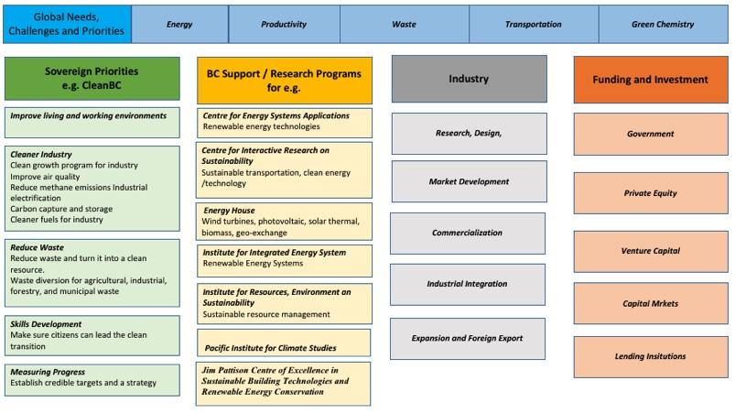

Financial Overview
The global market for clean technologies is rapidly expanding. Estimates are that the global market is worth over US$1 trillion. In low-carbon, energy-efficient technologies alone trade is expected to almost triple by 2020. An increasing need for sustainable solutions such as green energy, paired with the pace of technological change, is driving the development of new climate solutions and economic opportunities that promise a sustained demand for clean technology. As an example, China will spend trillions over the next four years on clean water, air, food and energy as it turns from aggressive economic growth to sustainability. Consider also the EU’s climate change plan calls for a 20 per cent cut in greenhouse gasses by 2020.
In Canada there is a climate change agenda within the Federal Government that includes carbon pricing and increased low-emission transport and energy efficient buildings. The demand will be satisfied by domestic and foreign investment fueling growth of the clean technology sector. The sector is already a significant economic contributor to Canada’s GDP. In 2016 about 3% of Canada’s GDP (~$60 billion) was attributed to production of clean technologies, clean energy, waste management, and environmental goods and services. To approximate the clean technology contribution (separating out clean electricity and waste management), the remaining environmental and clean technology activity accounted for 1.4% of Canada’s 2016 GDP.
In a March 2018 report by Smart Prosperity, a national research network and policy think-tank based at the University of Ottawa, the Canadian clean tech sector employs more than 55,000 workers, and is poised to grow. It has been estimated the sector in Canada could export as much as $20B by 2025 (Figure 11).
Figure 11 Canada’s Clean Technology Exports 2016 and projection for future targets.
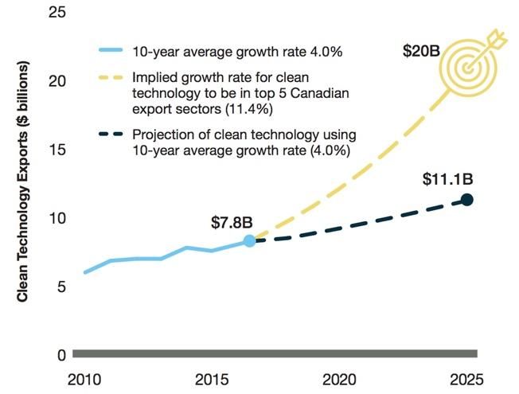
In British Columbia, which boasts the majority of clean tech enterprise in the country, equity to fund company growth comes from a variety of sources but the vast majority is BC in origin. Over the past decade sources of equity have moved away from the United States and Europe in favour of more domestic and Asian funding. This demographic shift may be more a function of a general tone of trade diversification in Canada.
The average revenue from BC Clean Tech firms is estimated to be $7 million based on 2017 projections with an expected total revenue stream in the vicinity of $1B. In a 2016 survey KPMG identified nine firms identifying as clean tech on Vancouver Island. This estimate is probably low as many Island companies do not consider themselves as servicing the greening of the economy. Total annual revenues from Clean Tech companies on Vancouver Island could be as high as $75 million. There is a critical mass of engineering and technologist skill sets on the Island with increasing access to university and college graduates suggesting growth in this sector will continue and could be enhanced by foreign direct investment.

Summary and Recommendations
By-en-large the global appetite for international trade is increasing. Countries and even regions within countries are vying to be seen as the “the best” place to do business while promoting their competitive advantages. VIEA, in being the only non-government organization with a mandate to promote the Island’s economic growth, has embraced the role of global-marketer of VI’s business opportunity. It recognizes that the first step in developing a good marketing plan is knowing your product and knowing your customer. Developing business cases, starting with the Wood Products Business Cases in 2017, and continuing through this report, is a prime example of the development of these market insights.
In producing this report, we took the pulse of the business community through a process of reaching out to community thought leaders and gauging the enthusiasm for taking local businesses to international markets. Being on an Island, with wondrous nature all around, risk aversion and complacency are naturally looming in the background. However, from our thought-leader discussions, it became clear quite rapidly that there is an eagerness for exploring options for international trade, with companies eagerly participating in discussions that will lead to greater exports.
The diversity of Vancouver Island business is a microcosm of the Canadian business community and there is no shortage of ideas reflecting global trends in goods and services. Our mandate was to present business cases across many VI sectors, with a view to bringing the “low-hanging” fruit to the fore. This was done by establishing a long list and, using criteria developed specifically for the purpose of this project, reducing the long list to those opportunities considered to be reasonable targets for foreign direct investment. Not surprisingly, the short list has elements that are influenced by Island-driven non-market forces. Suffice to say that if the opportunities to generate large profits, family-sustaining jobs, and community wealth did not exist, there would be little incentive to raise the issues in public to the level at which it exists today.
The short list of opportunities is varied within the VI market and this diversity is reflected in the presentation of the individual business cases. Aquaculture, Marketable Waste Wood, Cultural Tourism and Clean Tech were selected as the business cases to be delivered at this time. Other business cases of similar interest to foreign direct investors should be addressed in the near future. With each of the cases, the goal was to describe products or services to be sold internationally. The business overview was presented in terms of the market landscape and the value chain. The value chain discussion was important because it reflects the potential of Island companies to take advantage of connections and partnerships that are readily available on Vancouver Island. For each case a review of the respective financial implications provides potential investors with key points to consider.
After engaging with VI communities and researching the marketplace, a number of ideas were identified that may warrant further investigation. These are presented here in the form of recommendations:
- There is a common thread passing through three of the four cases presented here. This is the role that First Nations will play in the future economic development of the Island. In tourism. aquaculture and forestry, land ownership and access is on the critical path to successfully pursuing economic growth and attracting foreign direct investment. We recommend a dialogue be initiated between the business arms of FN governments, the investment community with deep knowledge of foreign investment market, representatives from three levels of government, and local export business experts. The purpose would be to discuss and support First Nations business strategic plans across the Island.
- There may be considerable opportunity in the development of a more integrated food distribution network on Vancouver Island. Initial discussion with a large US-based food company indicated a willingness to invest more on the Island to support localization of their product base and reduce the carbon footprint by reducing transportation costs. This opportunity should be further explored in conversation with the “Island Good” initiative established by VIEA.
- Information is available on the free trade agreements to which Canada is a signatory. To fully maximize the details within each agreement, we recommend that trade specialists be engaged to explore the targeted business cases and, of equal importance, to advise on structuring the business case presentations to best address specific interests and concerns of prospective international investors.
- To take advantage of the groundwork laid through this initiative, these FDI opportunities should be used to seed B2B discussion at the upcoming VIEA Business Match conference due to be held in March of 2019.
- Business match-makers should travel to meet with prospective foreign investors, developing relationships, and further refining the understanding of needs, strengthening the ability to intelligently respond to concerns and expressions of interest.
- The community engagement process identified potential international partners that are capable of translating the FDI ideas into country-specific marketable information. The documentation will be useful in gauging interest or soliciting further discussions. These opportunities should be explored further.
- Building on the initial funding to conduct research, engage stakeholders and develop business cases, the foundation is now laid for pro-actively and aggressively pursuing foreign investment. At the moment, the trend on VI is be reactionary in response to random requests for information. While individual communities may have developed capacity to market certain features available in their jurisdictions, such efforts tend to be narrow focused and limited in their reach. Establishing an Island-based FDI office under the auspices of the Foreign Trade Zone designation currently held by VIEA, will unify and strengthen the voice. For example, there was opportunity this past year to accompany an Island-based entrepreneur seeking closer ties to an Asian customer. Having an established VI FDI office may have helped in creating an opportunity for meeting directly with potential investors, while enhancing meeting preparations productivity.
- It is clear that successfully delivering foreign direct investment in Canada is as much a function of global demand as it is what Vancouver Island has to offer. To that end, any further development of Vancouver Island Foreign Direct Investment business cases must include a more exhaustive “buy-side” demand component. Emphasis will need to be placed on understanding the risk framework of investors target trade partner markets so as to present opportunities in a manner that will satisfy primary interests and concerns from the buyer's perspective. The portfolio of business cases should be used as specific and tangible investment products to be marketed directly to foreign investors in related sectors. Presentations could be tailored so as to address the risk concerns that are specific and unique to each prospect.

Appendix A The Team
Bill Collins
The team was led by Mr. Bill Collins, a consultant and principal of CollinsWorks Ventures Inc. Bill has more than 30 years’ experience in R&D, global sales and marketing, advanced manufacturing and M&A activities from bases in Canada, Europe, the South Pacific and the United States. For the past 15 years Bill has been on the leadership team for Quester Tangent, a BC based enterprise delivering engineering centric, complex technology. Bill is a member of the Professional Engineering and Geoscientists Association of British Columbia. Bill has been an evangelist for the growth of a vibrant advanced manufacturing sector on Vancouver Island.
John McCannel
John has over 35 years’ experience gained across a variety of roles in the Financial Services industry including: High Technology expertise in the areas of Advanced Manufacturing, Information Technology, Life Sciences, Clean Tech, and Digital Media. John has specific experience in Foreign Trade and Foreign Direct Investment as well as real estate and project financing.

Appendix B Round of Thirty
Key priority areas as identified in the VIEA ‘State of the Island’ Economic Report of 2017 were used as starting points to identify opportunities. Each opportunity is loosely defined and then measured subjectively against the criteria. Scores were given only as a guide with 1 being worst and 5 best. Final choices were made following community discussions.
Sector |  | Revenue | Profits | Employment Potential | Competitive advantage | Market access | Capital  Intensity | Level of maturity | Timing | VI Premium
Tourism | Tour buses (hop on and hop off), boat & ship cruises | 3 | 3 | 4 | 3 | 1 | 1 | 4 | 5 | 5
 | Eco-tourism | 4 | 3 | 3 | 2 | 4 | 5 | 4 | 5 | 3
 | Business Tourism | 1 | 3 | 2 | 3 | 1 | 2 | 1 | 4 | 4
 | Partnerships with travel agencies (Holiday + transportation packages) | 2 | 4 | 3 | 4 | 5 | 1 | 4 | 5 | 5
Agriculture | More organic food produce | 4 | 4 | 5 | 5 | 5 | 2 | 3 | 3 | 5
 | Value-adding to fruits & veggies | 4 | 4 | 5 | 3 | 5 | 1 | 2 | 5 | 4
 | Increase in livestock produce | 3 | 4 | 5 | 3 | 5 | 1 | 2 | 3 | 3
 | Expansion of vineyards; wine production and export | 4 | 5 | 5 | 4 | 5 | 1 | 4 | 4 | 4
 | Dairy Farming & production | 2 |  | 5 |  | 5 | 1 | 4 | 5 | 5
Aquaculture | Salmon canning & packaging | 5 | 5 | 5 | 5 | 5 | 4 | 5 | 4 | 5
 | Shellfish research centres & Institutes, fish plants | 3 | 3 | 4 | 4 | 5 | 1 | 3 | 5 | 2
 | Provision of equipment & supplies | 1 | 2 | 2 | 4 | 2 | 5 | 5 | 5 | 2
 | Technical support services to the aquaculture industry(Installation, assessment & monitoring) | 3 | 2 | 4 | 5 | 3 | 2 | 3 | 5 | 2
Manufacturing | Manufacture of detergents | 1 | 1 | 4 | 1 | 1 | 4 | 1 | 1 | 1
 | Production of soft ply. Tissue, napkins and paper | 2 | 2 | 5 | 2 | 2 | 1 | 5 | 3 | 2
 | Manufacture of herbs and cereals | 1 | 1 | 5 | 1 | 5 | 2 | 1 | 2 | 2
Forestry | Manufacture of Cross Laminated Timber | 4 | 2 | 2 | 5 | 4 | 1 | 3 | 5 | 3
 | Wood pellets as form of energy | 3 | 3 | 3 | 4 | 5 | 3 | 5 | 5 | 4
 | Forest and Land Management | 5 | 5 | 5 | 1 | 1 | 4 | 5 | 5 | 1
 | Value- added wood products | 5 | 5 | 5 | 5 | 4 | 2 | 5 | 4 | 4
 | Wood fibre Insulation | 1 | 1 | 2 | 1 | 1 | 1 | 2 | 3 | 1
High-Tech | Electric car production | 5 | 5 | 2 | 5 | 5 | 1 | 3 | 5 | 5
 | Robotics | 5 | 5 | 4 | 4 | 4 | 1 | 4 | 5 | 5
 | Renewable Energy | 4 | 4 | 3 | 4 | 3 | 2 | 5 | 5 | 5
 | Green Building & Clean water technology | 1 | 1 | 4 | 1 | 1 | 2 | 2 | 5 | 5

Appendix C Focus Group Template
A common approach was needed to assess the size and impact of each opportunity. The team found it useful to cast the prioritization criteria in terms of impact on the Income Statement and Balance Sheet. These key indicators are common to all business. By focusing attention on extracting this information, focus groups were encouraged to think beyond the normal course of executing a business. Most attendees were not financial professionals so the attention was not necessarily on generating numbers but on assessing the risk and rewards that would be key indicators to a foreign direct investor.

Criteria | Income Statement | Balance Sheet
Revenue | •Rev. - Stability, Cyclicality  •COGS – Known cost base?
Wealth Generation | •Multiplier  •Trickle Down  •Community Wealth | •Rate of Wealth creation
Employment | •#’s  •FT/PT/FTE implications  •Quality/Skills  •Availability  •Training
Location | •Import/Export  •Logistics  •Foreshore lease | •Land?  •Bldg. ?  •Equipment
Market Access | •Marketing
Capital Intensity | •COGS (Leases) | •Capex  •Amounts (H $10M+, M $5 +/- $2M, L <$1M  •Complexity
Level of Maturity | •Revenue Stability  •Known Cost Base  •R&D

Vancouver Island Transportation Forum/Plan, VIEA 2015, http://viea.ca/economic-resources-initiatives/initiatives/vancouver-island-transportation-forumplan/
Capturing Talent. VIEA 2017, http://viea.ca/economic-resources-initiatives/initiatives/capturing-talent/
State of the Island Economic Report, VIEA 2018, http://viea.ca/economic-resources-initiatives/resources/state-of-the-island-report/
Wood Products Business Cases, VIEA 2017, http://viea.ca/wp-content/uploads/2016/04/Wood-Products-Business-Case-Final-Report-1.pdf
Application for Foreign Zone Designation, 2018, http://viea.ca/wp-content/uploads/2016/04/VIEA-FTZ-Application-Vancouver-Island-revised-1.pdf
2017 Economic Report, VIEA 2017, http://viea.ca/wp-content/uploads/2017/11/2017-VIEA-Economic-Report-WEB.pdf
Capturing Talent on Vancouver Island, 2017 http://viea.ca/wp-content/uploads/2017/09/Capturing-Talent-on-Vancouver-Island-Presentation.pdf
http://www2.gov.bc.ca/gov/content/governments/about-the-bc-government/regulatory-reform/red-tape-reduction
Why Kelp? http://canadiankelp.com/why-kelp/
Seaweeds as a source of nutritionally beneficial compounds – A review, (2008), Chandini, Shantha & Ponesakki, Ganesan & P V, Suresh & Bhaskar, N. Journal of Food Science and Technology -Mysore-. 45. 1-13.
The State of World Fisheries and Aquaculture, 2018, Food and Agriculture Organization of the United Nations. http://www.fao.org/3/i9540en/I9540EN.pdf
Canada’s Fisheries Fasts Facts 2017, http://www.dfo-mpo.gc.ca/stats/facts-Info-17-eng.htm
State of the Island Economic Report, http://viea.ca/economic-resources/state-of-the-island-report-download/
Fisheries and Aquaculture Country Profiles, The Republic of South Korea, 2017, Food and Agriculture Organization of the United Nations, http://www.fao.org/fishery/facp/KOR/en
http://canadiankelp.com/ , https://seafloraskincare.com/
The State of the World Fisheries and Aquaculture, 2018, Food and Agriculture Organization of the United Nations, http://www.fao.org/state-of-fisheries-aquaculture/en/
Canadian-owned land-based fish farm goes bankrupt, November 2018 SeaWestNews https://www.seawestnews.com/canadian-owned-land-based-fish-farm-goes-bankrupt/
Feed Conversion Ratio for Farmed Fish, https://www.aqua-techna.com/en/productivity/experts/feed-conversion-ratio-farmed-fish
Wood Packaging Materials Market Application and Industrial Growth, 2018, https://globenewswire.com/news-release/2018/02/28/1401033/0/en/Wood-Packaging-Materials-Market-Application-and-Industrial-Growth-Profshare-Market-Research.html
http://www.timcon.org/Manufacturers/FactSheets/
Industry Canada’s baseline financial performance Forestry and Logging, https://www.ic.gc.ca/app/scr/app/cis/performance/rev/113
Conversation with Shaman Ferraro, Cannabis Tourism Expert, www.cannago.ca
Tourism HR Resources for Employers and Job Seekers in Vancouver Island, https://www.go2hr.ca/regions/vancouver-island
2017-2018 Annual Report, Indigenous Tourism Association of Canada, https://indigenoustourism.ca/corporate/wp-content/uploads/2018/07/ITAC-2017-18-Year-End-Report.pdf
German Market Highlights, Destination Canada, 2018 https://www.destinationcanada.com/sites/default/files/archive/306-market-highlights-germany/de-markethighlights_en_2018.pdf
Global Tourism Watch, 2017 Germany Public Tourism Watch, Destination Canada, https://www.destinationcanada.com/sites/default/files/archive/739-Global%20Tourism%20Watch%20-%20Germany%20-%202017/2017%20GTW%20Germany%20Summary%20Report_Public_English.pdf
Eight Reasons Why German Tourists Flock to Canada’s Yukon Every Year, 2018, https://www.cbc.ca/cbcdocspov/features/eight-reasons-why-german-tourists-flock-to-canadas-yukon-every-year
IATA Annual Review 2018, https://www.iata.org/publications/Documents/iata-annual-review-2018.pdf
BC Labour Market Outlook 2018 Edition, https://www.workbc.ca/Labour-Market-Industry/Labour-Market-Outlook.aspx
WorkBC Industry Outlook Profile, Tourism and Hospitality, 2018, https://www.workbc.ca/getmedia/56a669bb-7e6d-4270-8c64-6396c9aedb58/profile-tourism-and-hospitality-sector.pdf.aspx
BC Tourism Labour Market Strategy 2012, https://www.go2hr.ca/wp-content/uploads/2017/07/go2HR-TLMS-Communications.pdf
https://www.indigenousbc.com/drive/uploads/2018/10/REPORT-ITBC-Audit-2012-2017_FINAL.pdf
The Prize in Economic Sciences 2018, https://www.nobelprize.org/prizes/economic-sciences/2018/press-release/
CleanBC. our nature. our power. our future. https://cleanbc.gov.bc.ca/
Export Development Canada, https://www.edc.ca/en/blog/cleantech-canada-growing-global-markets.html
The Innovation and Competitiveness Imperative: Seizing Opportunities for Growth Report of Canada’s Economic Strategy Tables: Clean Technology https://www.ic.gc.ca/eic/site/098.nsf/vwapj/ISEDC_CleanTechnologies.pdf

